Caitlin Armfield
Deakin Authentic Teacher Assessment
Word count – 6, 509

Caitlin Armfield 900 189 794 Secondary Stream – Science and Chemistry
6/5/2013

Table of Contents
Section 1: Contexts for Teaching and Learning 2
1.1 School 2
1.2 Commentary and Photographs 3
Section 2: Planning and Teaching 5
2.1 My Class – Students as Learners 5
2.2 Planning 7
2.2.1 Rationale 7
2.2.2 Planning 8
2.3 Teaching 9
2.3.1 Curriculum 9
2.3.2 Teaching Strategies 10
2.3.3 Learning Theories and Pedagogical Models 11
Section 3: Teaching For Learning 12
3.1 Students Learning 12
3.2 Teaching 13
Section 4: Assessing Student Learning 15
4.1 Whole Class Assessment 15
4.2 Students Feedback 20
Section 5: Reflecting on Teaching and Learning 25
5.1 Students as Learners 28
5.2 Myself as a Teacher: Ready to Teach 30
References 31
Appendix 1 – Lesson Sequence 33
Appendix 3 – Assessment Task 47
Appendix 4 - Journal 49
Appendix 5 – Practicum Report 75

Section 1: Contexts for Teaching and Learning

School
The context in which a school is situated can have a great effect on the teaching and learning that can or will occur within it. UHS is a co-ed government school located on the outer eastern suburban fringe; the data in table 1 shows the school to be on average academically with other schools both different and similar to it in context. As it sits on the edge of the Sherbrook forest and is in close proximity to the Dandenong Ranges National Park it has a very unique and beneficial geographical context. The school was the first in its area and boasts the fact that many consecutive generations of families have attended the school. This gives the school strong ties to the community and sense of belonging in the school environment. The cultural background of most students is Caucasian Australian; from table 1 it is clear that there is very little ethnic diversity within the school.

Table 1 – School Context
School Sector/Type | Metropolitan Government coeducational school
Year Range | 7 - 12
Enrolment History | 933 (2012)
Location | Yarra Ranges District
Curriculum | VCE, VET and VCAL pathways
Core Values/ School Motto | Preparing the Leaders of Tomorrow
Teaching Staff | 74
Non-teaching Staff | 45
Student Attendance Rate | 79%
Yr 12 Results (2012) | Average Study Score – 28 Percentage study Score > 40 – 3.9
Post School Destinations (2011) | Students at University |  | Students at TAFE/ Vocational Study |  | Students in Employment
 | 40% |  | 26% |  | 11%
NAPLAN Data 2012 |  | Reading | Writing | Spelling | Grammar | Numeracy
Year 7 | SIM | Above | Average | Average | Average | Average
 | ALL | Average | Average | Average | Average | Average
Year 9 | SIM | Average | Below | Below | Average | Average
 | ALL | Average | Below | Below | Average | Average
Indigenous Students | 1%
Language background other than English | 4%
Source: Myschool website, ACARA, 2012

Commentary and Photographs
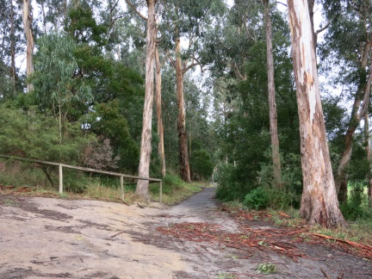
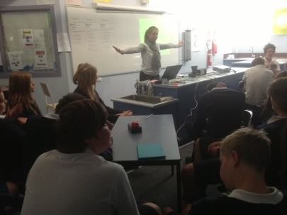
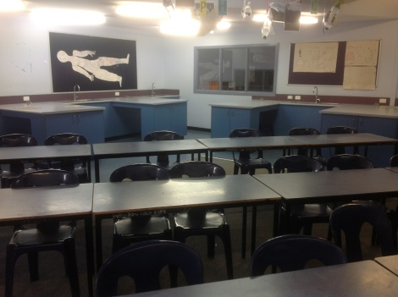
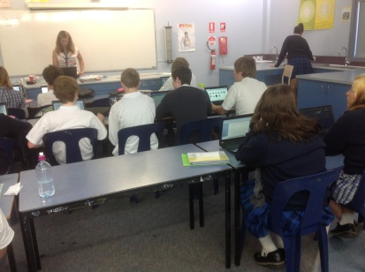
The school offers a variety of learning spaces for the students including well equipped science labs, flexible open planned learning areas and many outdoor spaces that can be used by more than just the P.E department. From a science perspective having spaces like the embankment (figure 1) offer the students opportunities to participate in field work within the school grounds which is directly related to their unique context. Having well equipped and set out science classrooms (figure 2) that facilitate quality group and practical work are a great advantage for the students. The school has a laptop program (figure 3) that was funded by the government which enabled all students in years 9, 10, 11 and 12 to have a laptop. That money is now mostly gone meaning that if the students currently in the junior school wish to take part in the program in coming years they will need to buy the laptops as part of their booklist. Apart from the senior laptop program there is a lack of ICT resources within the science classrooms with things like projectors and interactive white boards not present or require a lot of setting up. This makes incorporating learning technologies more difficult but this can often challenge teachers to come up with very creative strategies such as revision jeopardy. (Figure 4) The school also is a Tribes Learning Community which is a process that facilitates collaborative learning through creating a safe learning environment; all staff are trained in this process.
Fig 4 – Yr 10 class using game show buzzers in a revision game.
Fig 3 – Students using their laptops in class
Fig 2 – Science classroom
Fig 1 – School grounds contain a large area of bushland that can be used as a learning area.

Section 2: Planning and Teaching

2.1 My Class – Students as Learners

Table 2 – My Class
Year Level | 8
Subject | Science
Topic | Energy
Number of Students | 21
Boy : Girl Ratio | 9 : 12
Cultural Diversity | Not evident
Languages spoken | English
Aboriginal and Torres Strait Islander People | 0
% Language other than English | 0
Learning Styles | Visual, kinaesthetic, verbal/linguistic

Table 3 – Students as Learners: My Class
Students as Learners | Illustration | Analysis
Social development and relationships with their peers | ‘There was one student ‘J’ who was very isolated and didn’t want to participate in the group work and was quite content to just sit and do the work without participating.’  ‘Their teachers all agree that they are a nice group to teach and that there is a very positive learning environment within this class across the different subjects.  The kids do sit in their friendship groups given the choice but don’t appear to make a fuss if they are required to work with other students in the class.’ | This created difficulty when doing group work as when he was put into a social situation he froze and stopped participating. This made it difficult for him to socially construct knowledge as he wouldn’t discuss with the other students. I dealt with this by letting him work independently but making sure I had discussions about the learning with him so that he wasn’t disadvantaged.  This made doing group work very easy and it also contributed to the ability of the students to put forward their thoughts and ideas without fear of ridicule. This was very important in the knowledge table activity and is the reason why it worked so well.
Intellectual development | ‘After the first period was finished we played a few short games to give the students a break before jumping in to more content which appeared to allow them to continue to focus most of the way through the second period.’  ‘Another student said that she ‘can’t do this because I can’t write things in my own words.’ We then talked this through guiding her and she needed a lot of support to be able to paraphrase what she had read. She was able to show some basic understanding of the concept. I tried to teach both of these students some literacy strategies individually as they were struggling with interpreting the information regardless of their scientific understanding.’ | It is a lot to expect of an adolescent to sit and focus for an hour and a half at a time. By breaking the time up with some games the students are able to regain focus they may have been losing. It also provides an opportunity to lift the energy in the room and increase engagement.  It is important to be aware that some students’ literacy skills aren’t as strong as they should be at this level. This demonstrates the need to incorporate literacy strategies into all classes and to explicitly teach some of these skills such as paraphrasing. From this experience it would have been beneficial to have done an activity around paraphrasing before starting the assignment as it was a common difficulty among the students.
Wellbeing | ‘One student was quite distressed when he came into class and had tears in his eyes, I asked if he needed a moment or wanted to sit in a quiet place for the lesson to try and get his assignment done so as to give him a chance to collect himself. Later 6 boys were taken out of my class by the AP to talk about a bullying incident that had happened in the past day and that lunch time.’ | Incidents of bullying are a common occurrence in secondary schools and dealing with distressed students is an important skill. By offering the student an out or opportunity to collect himself I was able to show I had noticed something was wrong but he was able to maintain his dignity by it being a private conversation between us. This is important when dealing with upset students.

2.2 Planning

2.2.1 Rationale

Energy is all around us in our everyday life and has a great influence on many of the decisions we have to make for our own future and the future of the world. By understanding the forms of energy and how they are transferred and transformed students can develop skills that they will need in their daily life. Some examples include being able to understand the energy requirements of their bodies and what they need to eat to meet those requirements without exceeding them and understanding energy efficiency ratings on electronic appliances and what they mean. To do these things students will need a conceptual understanding of energy in their life.

The learning foci for this unit are:
- Energy is all around us in many forms and is what is responsible for making things happen
- Things happen through a transfer or transformation of energy, some transfers and transformations are more efficient than others.
- Energy efficiency is an important aspect of 21st century life.
If students can grasp these concepts of energy they will have the understanding and skills to make informed decisions about issues involving energy both personally and in a wider context.

2.2.2 Planning

The work that made up this unit was planned using three main sources of information. The first is the Australian curriculum (ACARA, 2012) which gave the central concepts that the students should understand and skills they will have developed by the end of the unit. The second was the text book that the students were all required to have; Pearson Science 8 (Rickard, 2011), and offered some good base material and practical exercises. The last source was the students and what they already knew and what they wanted to find out about the topic. Tying all these things together into a cohesive unit allowed for a flexible approach to planning that would still meet the outcomes outlined in the Australian curriculum. The last source was the most important as it was what kept the students engaged in the topic from start to finish. This type of planning is an example of a democratic planning style which gives the students more ownership of what they learn making it more meaningful to them.
The unit began with two activities; a knowledge table and a post-box strategy that were used as diagnostic assessments to inform the content and planning of the rest of the unit. (Appendix 1, Lesson 1) Students were able to demonstrate what they already knew about energy and develop research questions about what they would like to find out about energy. I was able to assess their prior knowledge and gather information about their interests and their level of thinking, as well as identify any alternative conceptions that would need to be resolved. The alternative conception that energy can be created and destroyed was very prevalent with only one student in the class having the scientific view that it can’t. This informed my planning in that a lot of time would be spent on that concept within the unit (Appendix 1, Lessons 2-4). Over these few lessons a variety of teaching strategies were utilized to help with translation of the concept, these included demonstrations (lesson 1 & 2) which challenged the students to apply their understandings and make predictions, constructing multiple representations (lesson 3, 4 & 5) that challenged the students to demonstrate their understanding in different forms, practical investigation (lesson 4) and research tasks (Lesson 3 & 6) challenged students to apply their understandings to new and unfamiliar contexts. Basing the unit on the questions the students had at the start of the unit allowed the students set their own learning goals and it was my job to challenge them to reach them by the end of the learning sequence. By constructing a new knowledge table in the last lesson of the sequence (Lesson 8) the students were able to see that they had achieved the learning goals we had set together at the beginning of the unit. They were then also able to develop further questions demonstrating the idea that learning is an ongoing process that doesn’t stop just because you have finished studying a topic. (Armfield C, Journal Entry 23)
The teaching of this unit utilized many teaching resources but not very many ICT resources. The main resources used were worksheets and paper based activities as the students didn’t have any personal devices they could use in class. The students often had to used paper based resources given to them to construct representations in their books such as the pictures they had to use to make energy flow diagrams (Lesson 2) When the resources were available, using YouTube videos and other electronic resources as ‘hooks’ to get the students engaged in the lesson was a successful strategy. (Lesson 6) This was effective as “all eyes were on the screen for the entire time with comments of ‘that was cool’ once it had finished” (Armfield C, Journal Entry 20)

2.3 Teaching

2.3.1 Curriculum

The unit was planned according to the Australian curriculum (ACARA, 2012) in science for year 8 in the three strands: Science understanding, Science as a human endeavour and Science inquiry skills. Every lesson addressed the science understanding strand as that was the concepts being taught. I addressed the science as a human endeavour strand by incorporating an assignment about renewable energy. (Armfield C Journal Entry 4) The science inquiry skills were developed in lessons that facilitated it, such as generating inquiry questions (Lesson 1), communicating scientific information (All lessons) and interpreting data through investigation. (Lesson 4)

2.3.2 Teaching Strategies
During this unit on energy many teaching strategies were utilized, two of the strategies used most successfully were role play and practical investigation.

Role Play
Role play is a strategy that offers students a way to show or develop their understanding of a concept without having to write it down. (Przywolnik, 2004) This strategy was used in an introductory capacity (Lesson 5) when teaching the skill of calculating energy. This strategy was chosen as this concept can be difficult for students to articulate in the beginning and ‘calculating’ is often an intimidating term for some students. This experience involved the students selecting an item of food and then arranging themselves into a line from least to most energy, the students were engaged by having something physical of focus on and then a problem to solve. I was also able to assess the students understanding of kJ. From the role play students were able to come to the conclusion that if we know that there is more energy in one food than another there must be a way to calculate it. The students were able to show their understanding of the difference in amount of energy stored in food without having to articulate it with pen and paper.

Practical Investigation
The students participated in some practical investigation activities while studying this unit with some being investigations they completed in groups (Lesson 4) and some as demonstrations investigated as a class. (Lesson 1 & 2) Practical investigation is an effective teaching strategy in science as it encourages participation and autonomy in the students as well as opportunities for the students to visualise the science concepts being taught. (Toplis, 2012) It is important when conducting practical work in the science classroom that the type of inquiry is authentic and not recipe based. The main aspect that separates these recipe driven activities and authentic investigation is the level of critical thinking required. (Hackling, 2004) The practical investigation the student conducted (lesson 3) involved the students applying their understanding of forms of energy and energy transformations to everyday objects in a ‘hands on way’. Research has shown that hands on activities in science promote effective learning through peer interaction, object mediated learning and embodiment of the concepts. (Satterthwait, 2010) It was clear that this activity did help the students visualise the concept of forms of energy and make it tangible for them. The task was heavily scaffolded but it still had aspects of authentic inquiry as the students were required to create their own aim and then answer that aim in their conclusion.

2.3.3 Learning Theories and Pedagogical Models

The teaching of this unit required an understanding and application of multiple learning theories and pedagogical models. It contained elements of a democratic curriculum, constructivist teaching and learning theory, translation, the E5 instructional model and an inquiry based approach. Some of these are discussed below.
“The questions they came up with are now going to be the basis of the teaching of the topic through an inquiry based approach and is an example of when democratic curriculum works.” (Armfield C, Journal Entry 2) The students were able to decide and participate in the structure of the curriculum demonstrating the presence of an element of a democratic curriculum. The students also participated in designing one of their assessment tasks “During class the students expressed an interest in renewable energy and I hadn’t included that in the unit plan so this provided a great opportunity to address their interest” (Armfield C, Journal Entry 4) This also has elements of democratic curriculum in it as the decision wasn’t made purely by the adult/teacher, the students had a voice in what questions they wanted answers to and what they wanted to learn about their world. (Apple & Beane, 2007)
Throughout the unit the use of e5 instructional model was clear and is shown below.
Level | Description | Illustration
Engage | Stimulating activity that captures interest and allows students to express their current ideas | Students sharing their knowledge of and questions about energy in the knowledge table (Lesson 1)
Explore | Explore problem through hands on activities, common set of experiences to make sense of new ideas | Students identifying energy forms and transformations in everyday objects in demos and investigation (Lesson 2 & 4)
Explain | Scientific terms introduced to explain students new ideas | Given as summary notes on the board following demos and investigation (lesson 2 & 4)
Elaborate | Apply what they have learnt to new situations | Students apply concepts of energy forms and transformation to researching an energy source (Lesson 3 & 6)
Evaluate | Evaluate what has been learnt | Students answer the questions they had at the beginning of unit in knowledge table (Lesson 8)
Source: (Goodrum, 2004)
The constructivist learning theory states “Meaningful learning is the active construction of knowledge structures”(Churchill et al, 2011), as I view students as builders of their own knowledge not vessels to be filled with knowledge it was important to provide opportunities for the students to social construct their own knowledge with their peers. This was done through dialogic discourse between me, the students and their peers when exploring, explaining and applying new concepts and ideas.

Section 3: Teaching For Learning
This video recording (Appendix 2) was taken during the 5th lesson in the teaching sequence and shows the entire class participating in a role play teaching strategy. The purpose of the role play was to engage the students in the concept that energy can be calculated through a context they were familiar with; different foods contain different amounts of energy.

3.1 Students Learning
The main learning objective for this ‘hands on’ role play was for the students to engage in the idea that energy can be measured. This was achieved by using something familiar and physical that the student could engage with; food. By having the actual food items for the students to hold and examine the students were participating in object-mediated learning as the objects focused their attention and helped them form questions. (Satterthwait, 2010) This role required all students to participate which made it a very inclusive activity as even if they didn’t want to discuss with other students they still had to find a place on the line for their food item. As soon as the students had the food items in their hands they were engaged with many students looking and carefully examining what they had picked for clues as to what we would be doing. The group of girls on the left immediately started comparing their items and discussing what they thought we would be doing (0:58) this showed high levels of engagement from the beginning of the task. Two boys were sat out at the beginning as they were acting inappropriately (1:02); this was a good move as it set expectations for what was acceptable while completing the activity. The boys were then able to re-join the activity after a discussion was had about their behaviour. (4:00) Before starting the activity, through questioning, the students were able to recall the previous concepts taught in relation to what they were to be doing in this activity (2:13) doing this would aid them later in the lesson to make links between previous and new concepts which would make the learning more meaningful. Most students engaged in the task immediately with many students using their items to discuss how much energy was in them and where they fit on the line. (3:14) There were also some students that didn’t engage and weren’t picked up on it due to the chaotic nature of the activity. They remained in the same place the entire time and were obviously having discussions about unrelated topics. This can happen easily and needs to be addressed if it is occurring during a class or activity. The students were able to show a general understanding of the concept as when given a time limit they were able to form a line from least energy to most energy. (6:00) One student showed a high level of prior knowledge as she immediately came up and asked me if they could use the kJ information on the back of the packets (3:34) the fact that only a few students thought to do this showed me where their current understanding was and that would impact how I would approach the next task after the role play. The role play appeared to have been successful in engaging the students interest in the topic as when we were checking our predictions there was silence (8:28 – 9:45) There were also signs of engagement in the students making comments on their predictions and whether they were right or wrong (8:26)

3.2 Teaching
This role play was overall a successful strategy and I would use it again. It went almost completely to plan as I had run this activity with another class before but there were areas that I would like to improve if I were to do it again. Having all students participating was a major strength of this activity making it inclusive and active for all. Having objects to focus the students’ attention was also effective in engaging their interest. I need to extend my ‘wait time’ when questioning students (2:13) as I think I jumped in too early and didn’t give the students enough of a chance to think and provide an answer. During the explanation of the task and the reordering a group of boys managed to sneak outside my peripheral and I failed to notice what they were doing (2:20) & (9:24) Being able to keep an eye on what is going on with all students and running the activity is an essential skill that needs more development. A way this could be solved is have a student read the order out while I supervise the reordering. This would require a structured and safe learning environment where the students respect each other and listen to each other; this was present in this class and would have been a good solution to the problem. Enforcing an explicit time limit also helped keep the students engaged, when I gave them an approximate time frame (3:18) many students just stood around either talking or just standing. The opposite was shown when they had a time limit of the count of 10 (5:15-5:36) they jumped into action with only a few stragglers still unsure of where to go. If I were to do this again I would impose an explicit time limit of 1 minute and have a timer on my iPad or the board to show this visually to the students. The main area I need to work on from this video is my ability to be intuitively aware of what is going on in the entire room with all students which is a characteristic of the expert teacher. (Berliner, 1994) One way this aspect could be done better is by delegating roles to students so I can fully supervise the entire class.

Table 4 – Journal Entry from the Lesson
Day | Journal Entry
18 | The double with the year 8’s went really well and offered a few challenges and situations I had to deal with. The first involved addressing the students who hadn’t handed in their assignments today which I knew I would have to do but wasn’t sure on how I would handle it. Most reasons it was late were that ‘the computer or email didn’t work’ That isn’t a good reason and we then discussed as a group what we could do if we knew that it wasn’t going to be in on time and how they can take responsibility of their own work. I felt this was important so that they learn something from this and understand that if there is a problem they need to let us know so that something can be done about it.  The warm up exercise and role play activities went really well, the challenge with this kind of teaching strategy is that certain students enjoy and want to participate in these classes more than others and making sure that all students are participating can be difficult. I noticed this in the first warm up exercise and altered it in the moment by having the balloon return to me and direct where it went more so that more students were included. The role play was very engaging as many of the students were talking about it rather than unrelated things throughout and liked having something tangible for them to focus on and use.  This lesson had some maths involved which proved easy for some students and quite difficult for others even though it was only basic addition, subtraction, multiplication and division. One student who usually struggles to complete work was the first to finish today as all of his friends were in the other room finishing their assignments; he also managed to complete the work correctly with no assistance. It was interesting to see what he is capable of when he isn’t distracted by his peers.  Having an altered version of the work sheet for the students with low literacy was great. It had more scaffolding and walked them through what they had to do in smaller steps. The student I gave it too was able to work more independently and consistently due to this than they have in other classes; it also stopped them from just copying what their friend had done. Keeping students on task when on computers is nearly impossible, this is an area where I need more experience and maybe research some strategies other teachers use.

Section 4: Assessing Student Learning

4.1 Whole Class Assessment

Assessment isn’t a one off event; it is a cycle that includes many forms of assessment depending on the intended purpose. At the beginning of the unit I did some assessment for the purpose of identifying the students’ prior knowledge and interest in the topic. As the purpose was to inform my planning of the unit and assess the students prior knowledge it can be classed as diagnostic formative assessment. (Marsh, 2010 p. 109) The second assessment task the students completed was an assignment on energy sources which incorporated the concepts of the topic into a topic of their choosing. This can be seen as formative assessment as it provides an opportunity to assess the students understanding and give feedback on areas that they showed a good understanding and areas in which they could improve on before their final summative assessment. (Marsh, 2010 p.109) The final assessment task was a topic test that can be seen as a summative assessment as it is allowing me to make a judgement of their understandings of the concepts and my teaching of the topic.
The assessment task being examined in this section is the poster assignment ‘Where does energy come from?’ (Appendix 3) The task was designed to assist the students in answering one of the questions that they came up with in class that wasn’t part of what I had planned for the unit. This task is an example of formative assessment and can also be classified as assessment as learning. The task required students to apply the concepts of energy learned in class to a topic of their choice. This task addressed all strands of the Australian curriculum for science as outlined in the table below.

Assessment Links to Curriculum Outcomes
Strand | Curriculum Statement | Illustration
Science Understanding | Physical Sciences  Energy appears in different forms including movement (kinetic energy), heat and potential energy, and causes change within systems | Students had to identify forms of energy and explain how it causes change in a system.
Science as a Human Endeavour | Use and Influence of Science  Science and technology contribute to finding solutions to a range of contemporary issues; these solutions may impact on other areas of society and involve ethical considerations | Students investigated the issue of renewable energy and how science is enabling us to solve the problem of limited resources.
Science Inquiry Skills | Communicating  Communicate ideas, findings and solutions to problems using scientific language and representations using digital technologies as appropriate | Students had to communicate, in their own words, the scientific ideas and solutions to this issue and use a variety of representations to do so. They also had to research and create their posters using ICT resources.
Source – ACARA, 2012, Curriculum F-10- Science
Classes and learning experiences can be differentiated in three ways; by content, process and product. By allowing students to choose a topic or aspect of a topic they are interested in provides greater motivation from the students (Wu, 2013) this task has been differentiated by content in that students were able to select a topic of their own choice and also choose some of the questions that they were to answer in their assignment. (See Appendix 3)

Table 5 – Assessment
Assessment Task | Assessment Type | Links To Curriculum Outcomes | Assessment Criteria
Create a poster about a source of energy. Students to research their chosen topic and apply their understanding of forms of energy and energy transformations. Students also to discover the difference between renewable and non-renewable energy sources, what this means for the environment and how science is offering solutions to the problems associated with sources of energy. | Formative assessment  Students would receive feedback on areas of understanding and areas needing improvement  Assessment as learning  Once students received feedback they had to identify what they did well, what needed improvement and something they could’ve done differently  Assessment for learning  Upon receiving the assignments I could clearly see which concepts the students had understood and the ones they hadn’t this informed my teaching for the rest of the sequence by showing which areas I taught well and which areas I had to try again differently.  Assessment of learning  The students are being asked to show their understanding of the science concepts taught so far. | See Assessment Links to Curriculum Outcomes table above | - Description of the chosen energy source that includes where the energy comes from and what it’s used for  - Identification of the forms of energy used and produced by the energy source  - Correct energy flow diagram that shows the energy transformation occurring for the energy source  - Shown whether the energy source is renewable or non-renewable and explained why  - Included 2 of the extra questions and answered them in detail  - Presented in a creative and engaging way  - Included a bibliography

Table 6 – Whole Class Assessment
Low Achieving
Average
High Achieving

Student | Criteria 1 | Criteria 2 | Criteria 3 | Criteria 4 | Criteria 5 | Criteria 6 | Criteria 7 | Total / 35 | % | Mark
A | 10 | 4 | 4 | 5 | 5 | 3 | 2 | 33 | 94 | HD
B | 0 |  |  |  |  |  |  | 0 | 0
C | 5 | 2 | 2 | 4 | 2 | 2 | 0 | 17 | 49 | NP
D | 5 | 2 | 2 | 4 | 5 | 2 | 0 | 20 | 57 | NP
E | 8 | 3 | 2 | 3 | 2 | 2 | 0 | 20 | 57 | NP
F | 5 | 3 | 2 | 1 | 2 | 1.5 | 0 | 14.5 | 41 | U
G | 8 | 2 | 0 | 2 | 2 | 2 | 1 | 17 | 49 | NP
H | 10 | 4 | 4 | 4 | 5 | 3 | 0 | 30 | 86 | D
I | 6 | 3 | 0 | 0 | 5 | 2 | 0 | 16 | 46 | NP
J | 10 | 3 | 2 | 2 | 3 | 3 | 0 | 23 | 66 | P
K | 6 | 3 | 3 | 4 | 5 | 2 | 0 | 23 | 66 | P
L | 6 | 3 | 2 | 4 | 3 | 3 | 0 | 21 | 60 | P
M | 6 | 1 | 1 | 3 | 1 | 2 | 2 | 16 | 46 | NP
N | 5 | 3 | 2 | 2 | 2 | 2 | 0 | 16 | 46 | NP
O | 10 | 4 | 5 | 3 | 3 | 2 | 0 | 27 | 77 | C
P | 6 | 2 | 5 | 1 | 2 | 2 | 0 | 18 | 51 | NP
Q | 4 | 1 | 1 | 1 | 3 | 2 | 0 | 12 | 34 | U
R | 8 | 3 | 4 | 3 | 2 | 3 | 0 | 23 | 66 | P
S | 5 | 3 | 3 | 2 | 2 | 1 | 0 | 16 | 46 | NP
Average | 6.5 | 2.7 | 2.4 | 2.7 | 3.0 | 2.2 | 0.3 | 19.1 | 54.7

As a class it can be said that generally the students were able to research their chosen energy sources quite well as the class average for criteria 1 was 6.5/10. From this it is clear that the students are quite proficient in researching using the internet. The students showed a clear understanding of the concept of renewable energy with the average of 3/5; this also supports the students’ decent researching skills as this concept wasn’t covered in class. Their understanding of the two concepts taught in class was shown to be moderately developed. The common mistake in addressing the concept of forms of energy evident in criteria 2 was that students confused forms of energy with sources of energy. This was then addressed in class before the end of topic test and the test results showed that this misconception had been resolved with nearly all students getting full marks on that question on the test. The energy flow diagrams; criteria 3 weren’t done very well, this wasn’t so much that the students didn’t understand the concept but they didn’t link the term energy flow diagram with what we had done in class. Again when I pointed out what they were the students could use them to show their understanding. Overall the students proved themselves capable of researching new topics and concepts and were able to show some understandings of the concepts being assessed. The greatest barrier they faced appeared to be the use of the scientific terms in the assessment criteria. From this it is clear that I could have spent more time in class defining the terminology and linking their class work to the different assessment criteria in the assignment.

4.2 Students Feedback

Student Work Samples
High Achieving – Student A
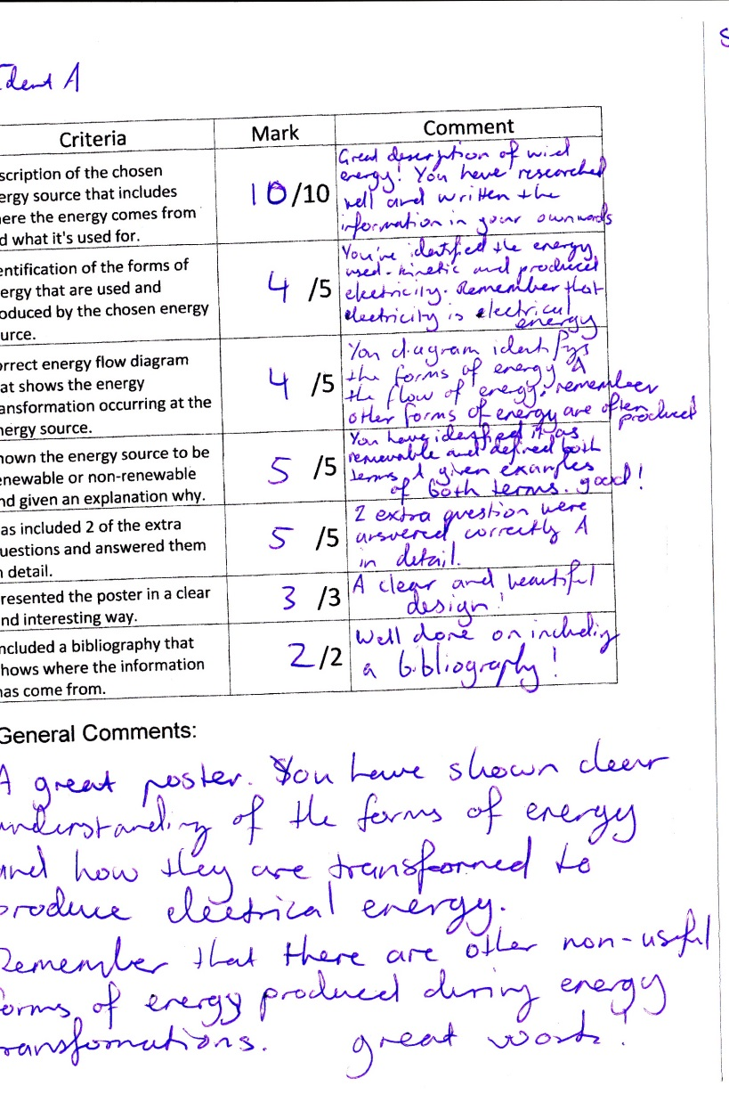
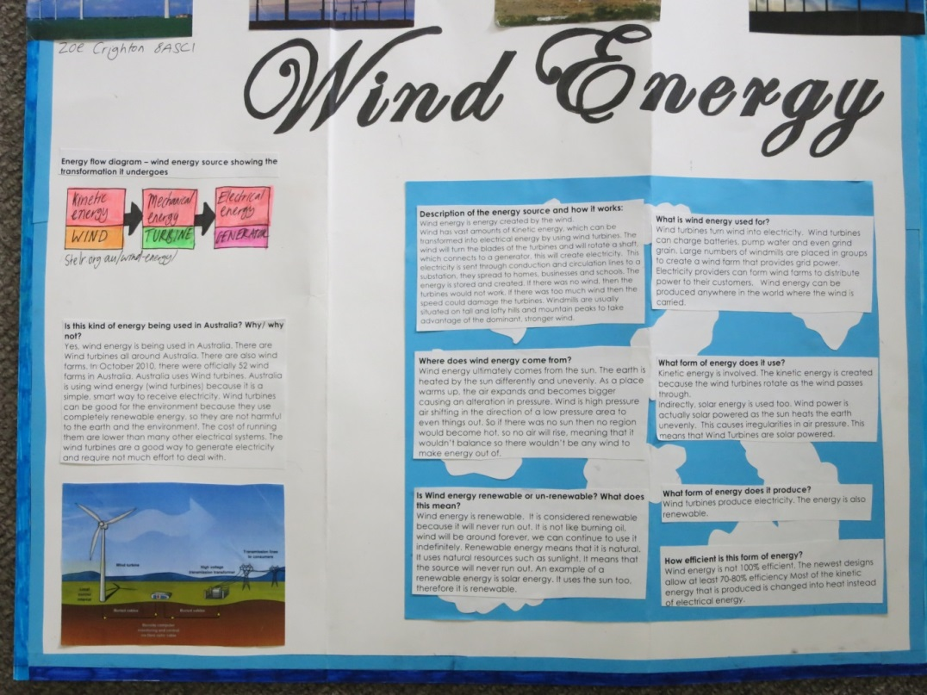

Average – Student J
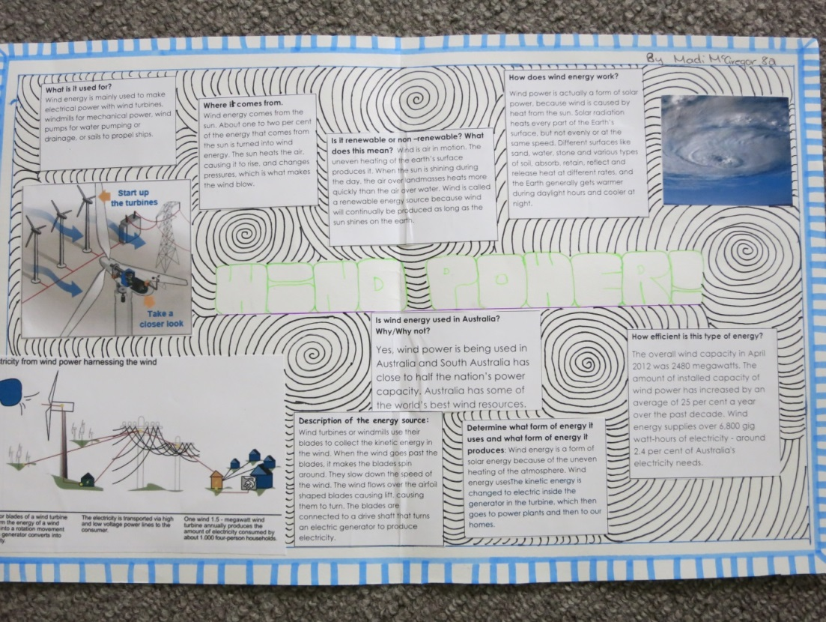

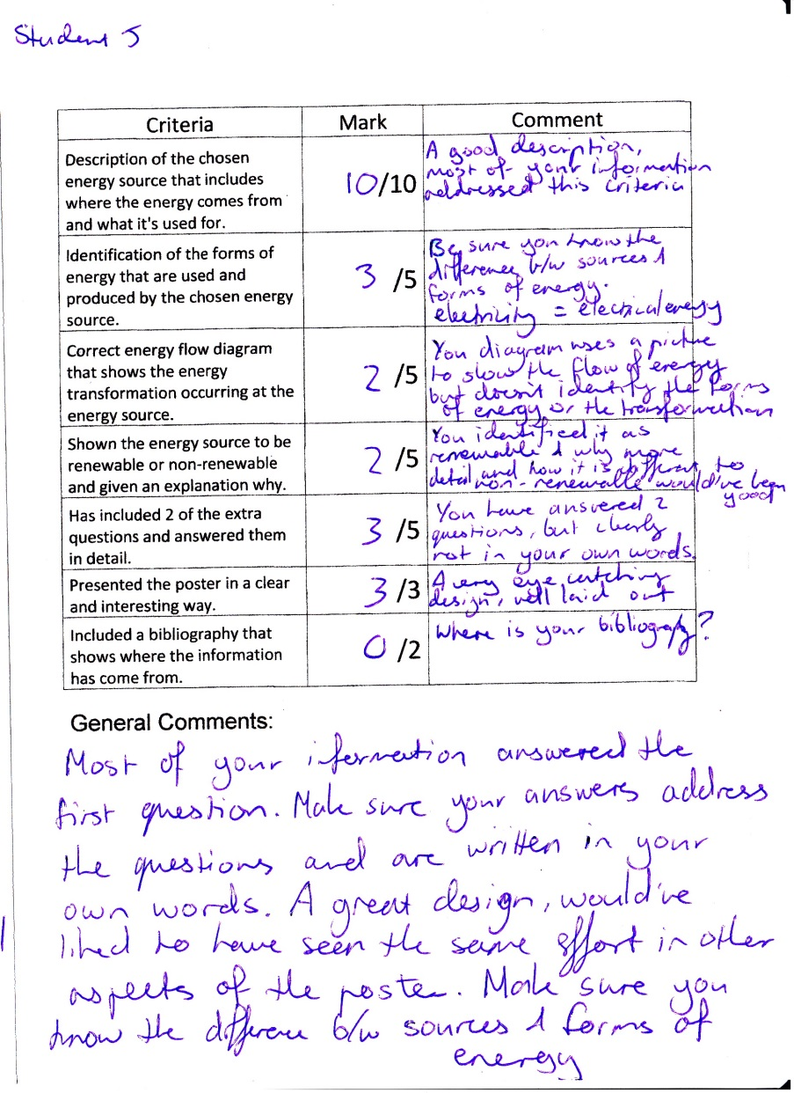
Low Achieving
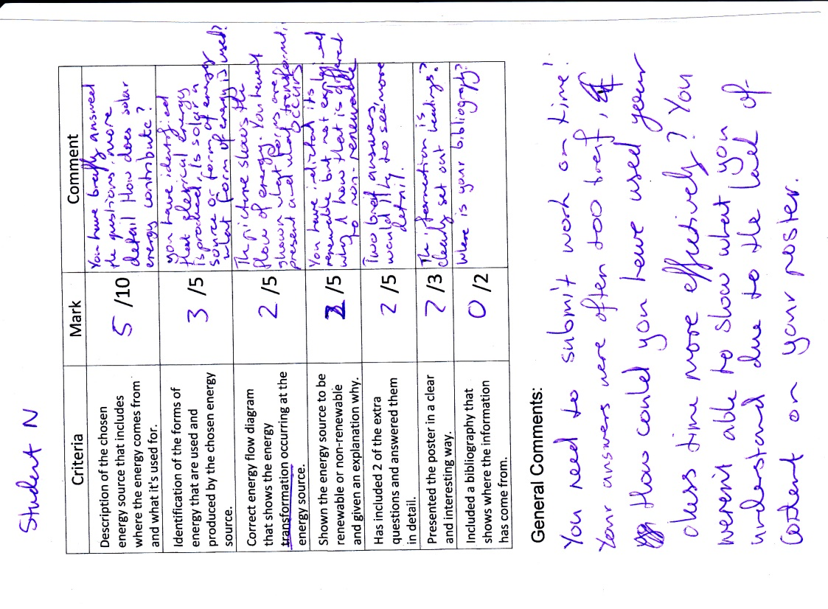
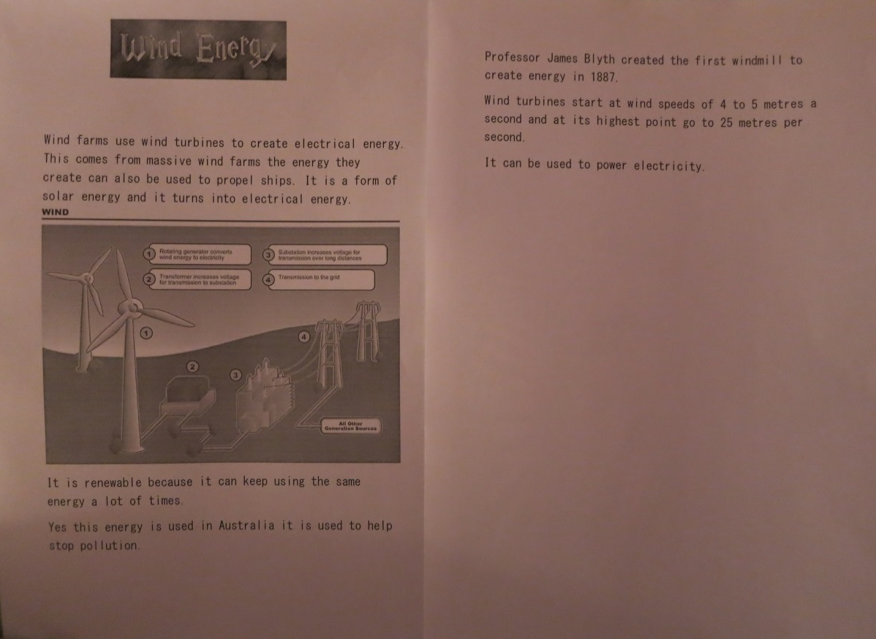

These three work samples of the ‘where does energy come from?’ formative assessment task (Appendix 3) show the range in students understanding at the mid-point of the unit. There are a few clear differences between the three students levels of understanding and abilities at this time, the high achieving student was able to address the research questions and write most of her answers in her own words, this is shown in the short sentences and drawn diagrams present on her poster. She was also able to use correct terminology and link the concepts learned in class to a new and unfamiliar context, this is clearly shown in her energy flow diagram that was draw using the same format used in class where the other two students cut and paste other examples from the internet, she was also the only student in the entire class to include a bibliography. This shows that she has a better understanding of how to read assessment criteria thoroughly. The average achieving students work showed that she was able to research the energy source but struggled to make solid connections between concepts learned in class with the new information. Many of the questions have similar answers with the same information being repeated over and over as in the four text boxes along the top. This shows that she was able to recognise the relevant terminology but couldn’t translate the information into her own words and interpret how it related to some of the concepts taught in class. She was able to show understanding of recalling terms such as the forms of energy but when asked to apply them to a context such as constructing an energy flow diagram she was unable to show complete understanding with that representation. The low achieving students work is an example of what he was able to complete in 40 minutes of a last chance catch up session. It showed limited understanding of the concepts and limited research abilities due to the small amount of content it contained. This isn’t an accurate representation of where his actual understanding was at as his class work told a different story. This student didn’t use his time well and was easily distracted by his peers in class resulting in a poor result for this task.
The feedback I gave to the students supported their learning by giving them a clear indication of which elements were done well and where they needed improvement. By commenting on each specific criterion they were receiving feedback that was specific to learning outcomes which they could then use to improve their understanding. (Glasson, 2009) Some of the feedback was posed as questions to the students rather than just telling them what they had missed all the time, this gives the students the responsibility to find out what they missed and rectifying that area in their learning. The general comments section allowed me to give advice on both content and non-content related areas of improvement. Content related issues such as clarifying the difference between energy forms and energy sources and that electricity should be referred to as electrical energy pointed students in the right direction in amending their understanding. Non-content related issues such as getting work in on time and answering each question in your own words also supported student learning as if the can improve these learning behaviours they will increase their ability to learn. This feedback could be improved by having gotten it back to the students quicker, I didn’t give the feedback until I had received most of the assignments and as many arrived a week late this was not immediate enough, feedback is most effective when it is given in a timely manner. Overall this feedback can be considered formative feedback as it identified what students did well and what needed improvement as well as offering specific advice. (Glasson, 2009)

Section 5: Reflecting on Teaching and Learning

Table 7 – Journal Extracts
Section | Journal Extracts | Entry
Students as Learners | The first activity was to get them thinking about the new topic I will start with them tomorrow and involved them identifying what they already know and things they would like to find out. All the students followed instructions well and came up with some very good questions. This was a surprise as most other times I have used this strategy the students haven’t participated very enthusiastically. The questions they came up with are now going to be the basis of the teaching of the topic through an inquiry based approach and is an example of when democratic curriculum works. Most students sat in social groups and worked well in them. | 2
 | As mentioned a complete rewrite of my lesson plan occurred as during the day I noticed students looking and feeling exhausted and my original plan had some role play in it. Getting tired kids to get up and move around is a struggle and often ends badly. Instead I created an investigation for the students to do which allowed them to use their new laptop that they were desperate to use and to also resolve a misconception that was made apparent in the last class. This also gave me the opportunity to have a chat to some of the students and to provide one on one support to those students who needed it. I also had a chance to teach them some things about using different computer programs such as excel. If the students are going to have these learning technologies then it is important for them to gain the necessary digital literacy skills to use them effectively. One change I would make for next time is if I show a student how to solve a simple formatting problem and notice other students are also having that problem, instead of teaching the class how to do I would allow the students I have taught to teach their peers how to do it. | 5
 | Saw one of my more difficult year nine students in the yard today and had a good conversations with her. I feel like we are forming a connection which will help in my interactions with her in class. It is amazing the attitude change in students when you give them a moment of your time to talk about them even if it’s about something a trivial as what you are having for lunch. | 12
 | The students have shown an improvement in getting their work done in class in the past few weeks, where in the last few lesson I had needed to really actively motivate and keep students on track but in this lesson the students were able to keep themselves on track and complete their research and plan in good time and to a high quality. I think this comes from the expectations I have set for them previously and they have realised that they can meet these challenges and feel good about themselves and their abilities. Students now believe in their own abilities. | 20
 | I only taught a single lesson with the year 8’s today. This lesson started really well, the students surprised me as they didn’t appear to mind that I separated them from their friends when we made the teams, this shows a high level of social maturity and that there are good relationships and respect between the students in the class. There were no moans or complaints just students keen to get going with the game. The students were excited to be doing something different and that there was a prize at the end. | 22
Myself as a Teacher | The lesson planned for today was introducing some new content building on the last topic which involved some board work followed by a drawing activity. This plan was thrown out the window after about 15 minutes as the class was behaving quite poorly and talking non-stop. This dynamic was very different to that of the last two classes I have had with them. What was different today was that some students who have been absent were present and were sitting with different people than normal. One girl in particular was being argumentative and disruptive to the whole class. She continued to be obviously disrespectful to me and push my buttons trying to get a reaction out of me. Her influence on the students around her was significant as students who would usually cooperate and participate followed and mimicked this girls’ poor behaviour. It got to the point where she was removed from the class and this had a positive effect on the rest of the class. I have never had to deal with disruptive girls before it has mostly been boys; generally boys are easier as they are often mucking around or getting distracted. These girls today were intentionally trying to get a reaction out of me and see how far they could push me which is quite different to my experience with boys. The class was a bit of a flop but now I think that the students have found my limit and will stay within it in the future. I engaged in a restorative discussion with the class at the end of the lesson having them identify what the problems were and what we should try to do next lesson. Next time I will use the script my mentor gave to try and neutralise the situation with the girl if it happens again. | 7
 | When the students were working on the computers on their assignments I found it easy to go around and talk to the students about what they were doing and found many students very focused on their work. I had a few conversations with some students that weren’t sure what to do or how to do it. One student said that he ‘just didn’t get it’ we then talked about what he had read and looked at a picture then described all the energy and what was happening to it in the picture. As we talked it through he showed a very high level of understanding of energy transformations and the ability to write it in his own words. Another student said that she ‘can’t do this because I can’t write things in my own words.’ We then talked this through guiding her and she needed a lot of support to be able to paraphrase what she had read. She was able to show some basic understanding of the concept. I tried to teach both of these students some literacy strategies individually as they were struggling with interpreting the information regardless of their scientific understanding. | 8
 | The warm up exercise and role play activities went really well, the challenge with this kind of teaching strategy is that certain students enjoy and want to participate in these classes more than others and making sure that all students are participating can be difficult. I noticed this in the first warm up exercise and altered it in the moment by having the balloon return to me and direct where it went more so that more students were included. The role play was very engaging as many of the students were talking about it rather than unrelated things throughout and liked having something tangible for them to focus on and use. | 18
 | The double revision lesson I took for the year11s was a hit and I felt like both I and the students enjoyed it. I used an interactive computer program to do some revision questions as a class. This very effective as I could pace the quiz one question at a time and we could discuss the questions further as a class before we moved on. There were some multiple choice questions followed by a few short answer questions just like the exam. The program also allowed me to track the students results by emailing me a report at the end, thus giving me a good idea of the students that are perhaps struggling with the content and also the areas where most of the class is struggling which I can then incorporate into some focused revision in next week’s class before the exam. The CRT commented on how much more relaxed and comfortable I seemed in this lesson and was impressed by my teaching style. I could definitely notice the difference as well. | 19
 | Today I wrote the topic test for the year eights, this was a very simple task as I had clearly outlined the unit in the beginning with clear learning goal and key ideas. This made writing the assessment task easy as I had a clear understanding of what the learning intentions were so that is what needed to be reflected. I also included different levels of blooms taxonomy and different modes of representation by having questions that required to label and draw diagrams rather than write answers. | 21

5.1 Students as Learners

My understanding of students as learners has greatly developed throughout this practicum especially in the areas of developing positive relationships with difficult students and what an impact it can make to include the students in the planning and assessment process. I have found that it also really important to acknowledge the students readiness to learn in your class. (Flannagan, 2009) The students in my year 8 class were at a much greater readiness to learn in a student centred way as they were enthusiastic about the topics and most students participated in tasks that required high levels of thinking. (Table 7 – entry 2) The opposite was seen in the year 8 class that I taught as whenever they were required to do any task that involved less rigid structure and required a lot of student input they switched off and it was a complete failure. (Table 7 – entry 7) It is clear that the year nine students were at a lower level of readiness to learn so they needed more scaffolding and support to gradually move towards those higher order thinking tasks.
During this placement and my experience with the year 8 class I discovered the benefits of implementing some aspects of a democratic curriculum (Apple & Beane, 2007) with a group of students that are engaged enough to positively contribute. Throughout the planning and teaching of the entire unit the content was based on what the students had wanted to find out, (Table 7 – entry 2) the effect this had on the students engagement was staggering. In most lessons all student would contribute to discussions and participate in activities as they were actually interested in what they were learning about. When they were having discussions in class it was often about their learning not unrelated topics. (Table 7 – entry 18) This wasn’t seen at all in the year 9 group where keeping them on task was almost impossible most of the time as it was clear that they had no interest in being in class and learning about chemistry.
I have also come to further understand the myriad of factors that can affect a students learning and their ability to engage in class. As I had many of my junior classes scheduled after lunch in period five or six I was able to see the huge effect this had on their ability to learn and engage. Students are often tired or restless at this point of the day and are reluctant to engage. (Table 7 – entry 5) This affected how I planned for these lessons often resulting in a total lesson plan rewrite or an alteration to a learning experience based on the time of day. By including tasks and experiences included some individual work or passive learning we could then build on that in the next class at a different time of day when the students are more ready to engage in higher levels or thinking.
The importance of developing positive relationships with students has always been clear to me and I have always felt that I’m good at developing relationships with students but the year 9 class really challenged me this placement and I learned a lot about the importance of the little things in developing relationships with difficult students. I had a bit of trouble with a group of girls (Table 7 – entry 7) our first few encounters were quite negative and I was stumped as what to do about it as I usually connect with the girls quite easily. I bumped into one of the girls when I was getting my lunch from the car and we had a chat about having noodles for lunch, (Table 7 – Entry 12) in the next class her attitude towards me had completely changed, she no longer ignored me or went out of her way to be disruptive. A similar experience with the other two girls out in the yard talking about shoes had the same effect on the other two girls. This demonstrated how important the little things that may seem trivial to us adults can have such a profound effect on a students’ attitude or disposition. This has helped me further understand that by showing some sort of interest in something as trivial as what they like to eat for lunch you can start to form that relationship and connect with the students.

5.2 Myself as a Teacher: Ready to Teach

During this professional experience I have been able to grow my professional knowledge in many different ways that I believe have lead me to being ready to begin teaching. I have increased my experience in implementing a variety of teaching strategies from traditional notes in VCE classes to interactive role play in my year 8 classes. (Table 7 – entry 18) I believe that I now have the knowledge to select appropriate strategies for the different classes I take and the content they are learning, I have also had the opportunity to do some intensive professional development in collaborative learning (Armfield C, Entry 24) that has left me with another set of strategies that I hope to implement in the future.
I have shown an ability to use appropriate planning strategies and processes for each of my very different classes that addressed their different levels of readiness to learn. This has been in more formal ways by writing unit plans and lesson plans that have allowed the students to learn not just content but better learning behaviours. (Table 7 – entry 20) It has also been in the more informal ways in changing the plan in the moment because your original plan isn’t working or you have finished everything you had planned and still have half an hour to go. (Table 7 – entry 7) This includes the ability to include the implementation ICT into the classroom in a meaningful way at all year levels. This was best seen in my year 11 biology class when their revision quiz using ICT provided the students and me with immediate feedback on their understanding as well as being extremely engaging. (Table 7 – entry 19)
I have also demonstrated the ability to address individual learning needs in class by working one-on-one with a few students that needed some extra support. (Table 7 – entry 8) The impact of this one-on-one interaction was seen in that students’ assignment when I marked it as most of the information was in her own words; she had taken the strategy we had used and practiced it to complete her assignment. Within any class there will be students with additional learning needs whether that is a learning disability, low literacy skills or other external factors. The ability to deal with and address these needs is essential to being an effective teacher (Marsh, 2010) whether it be by one-on-one teaching, differentiation or individualised learning plans it must be done.
I believe that I am now ready to begin teaching as I have demonstrated my ability to understand learners and learning as well as the ability to teach. Through the reflections and evidence presented in this document I have shown how I can get to know a group of diverse learners and plan a teaching and learning sequence relevant to their readiness to learn. I planned the sequence using a variety of planning strategies and processes including democratic curriculum and diagnostic assessment. This planning included a variety of teaching strategies to address the different learning needs within the class and some strategies that allowed me to address individual learning needs. Then I was able to assess their learning using both formative and summative assessment techniques that provided information and feedback to the students on where they were at in their understanding and what needed improvement as well as enabling me to make judgements on their learning. I also provided the students with the opportunity to reflect on their learning at the end of the unit allowing them to make judgements and connections to what they had learned while studying the unit. This shows that I am ready to enter the teaching profession and begin the next stage of my development as an educator by furthering my experience in the classroom and professional development within an established school learning environment.

References

ACARA, 2012, ‘F-10 Curriculum – Science’, http://www.australiancurriculum.edu.au/Science/Curriculum/F-10, 4/6/13
ACARA, 2012, Upwey High School: school profile, http://www.myschool.edu.au/SchoolProfile/Index/65930/UpweyHighSchool/45478/2012, 23/03/13
Apple M & Beane A, 2007, Democratic Schools: lessons in powerful education, Heinemann Educ Books, America
Berliner D, 1994, ‘Teacher Expertise’ in B Moon & A Shelton Mayes (eds) Teaching and Learning In the Secondary School, Routledge, London, pp 107-13
Churchill, Ferguson, Godinho, Johnson, Keddie, Letts, Mackay, McGill, Moss, Nagel, Nicholson & Vick, 2011, Teaching Making a Difference, John Wiley & Sons, Qld, Australia
Flannagan J, 2009, ‘Responding to Students Needs In Science’, The Delta Kappa Gamma Bulletin
Glasson T, 2009, ‘Effective Teacher Feedback’, Improving Student Achievement: a practical guide to assessment for learning, Curriculum corporation, Carlton South, pp 53-76
Goodrum D, 2004, ‘Teaching Strategies for Science Classrooms’, in Venville G & Dawson V (eds), The Art of Teaching Science, Allen & Unwin, NSW
Hackling M, 2004, ‘Investigating in Science’, in Venville G & Dawson V (eds), The Art of Teaching Science, Allen & Unwin, NSW
Marsh C, 2010, ‘Assessment and Reporting’ in EPR 702 Managing Teaching in Professional Experience: a custom edition for Deakin University, Pearson, Australia
Marsh C, 2010, ‘Meeting the Diverse Needs of Students’, In Becoming a Teacher: Knowledge, Skills and Issues, 5th Ed, pp 252-272, Pearson, Sydney
Pryzwolnik G, 2004, ‘Accessing Science Curriculum Resources’ in Venville G & Dawson V (eds), The Art of Teaching Science, Allen & Unwin, NSW
Rickard G, 2011, Pearson Science Year 8, Pearson Education Australia, Australia
Satterthwait D, 2010, ‘Why are ‘hands on’ science activities so effective for student learning?’, Teaching Science, Vol 56, Iss 2, pp 7-10
Toplis R, 2012, ‘Student’s Views about Secondary School Science Lessons: The Role of Practical Work’, Research in Science Education, Vol 42, Iss 3, pp 531-549
Wu E, 2013, ‘The Path Leading to Differentiation: an interview with Carol Tomlinson’, Journal of Advanced Academics, Vol24, Iss 2, pp 125-33

Appendix 1 – Lesson Sequence
1
Lesson in Sequence | 1 (double) | Year | 8 | Topic | Energy
Key Ideas / Learning Intentions | Find out what we already know about Energy  Find out what we would like to learn about energy  Energy is all around us  Energy causes change in our world  Energy can exist in many forms including being stored as potential energy
Links to Curriculum | Science Understanding - Energy appears in different forms including movement (kinetic energy), heat and potential energy, and causes change within systems  Inquiry Skills – Formulating questions and analysing data
Teaching Strategies | Knowledge Table- Identify prior knowledge, begin forming questions  Post box – diagnostic assessment  Dialogic discourse – discussion and questioning both open and closed  POE – Predict observe explain (demos)
Special Considerations | If running short on time each group only does one investigation and then reports back to the class. If time isn’t an issue students’ complete more than one task by rotating around the room.
Materials | Post box kit  Energy makes things happen lab  Permission forms for videoing
Procedure | Teacher |  | Student
Diagnostic assessment, identify prior knowledge and students interest in the topic. | Draw table on board and explain what it is about and what it is going to be used for. |  | Students identify what they already know and construct a set of questions that the unit will help them answer.
Identify students alternative conceptions using a post-box strategy | Hand out ‘what do I know about energy?’ sheets and explain that they just need to put what they think. Set up post box folders around the room |  | Complete the questions. Cut up the questions and post them in the post boxes (folders) set up around the room
Add to knowledge table | Instruct students to add one more thing to each column after they have completed the questions |  | Add one more thing to each column of their knowledge table
Students practice their analytical skills by identifying the classes current conceptions and construct more questions | Group students into five groups and give each group a post box and explain what they have to do with the answers.  Ask students to add one more thing to each column in their tables |  | In groups analyse the answers to the questions and then use the text to find out the ‘scientific view’ using the question sheet provided. Then add one more thing to each column of their table
Students communicate their findings to their peers | Lead a discussion based on the students’ findings and link it to what we already know and what we would like to find out. Add things to the table on the board as we go. |  | Students present their findings, then discuss what this means in terms of the knowledge table.
Create class table | Ask students to add things to either column in the table  Take photo and use that as a base for the study of the unit |  | Students write their additions on the board. They also add one more thing to the tables in their books.
Introduce idea of forms of energy through a think pair share brainstorming strategy | Guide students through think pair share |  | Brainstorm forms/types of energy individually, share with a partner and then share with the class and write them up on the board
Students investigate forms of energy | Add students ideas to the board and link ideas to the questions from table. |  | Students do a series of demos for the rest of the class and identify the forms of energy they can see.
Mentor Comments | Good behaviour management bringing the students attention back to their ground rules of manners and respect.  Great active involvement of student with demos, remember to check the students work books.  Be sure to write the key ideas/ learning attentions on the board at the start of the lesson  Could construct a summary paragraph at the end of the lesson.
My Comments | Lesson went well and students seemed engaged throughout most of the lesson participating in both activity and discussion. One boy Jacob is very isolated and doesn’t participate socially. All students got the work done one group of boys needed some strong encouragement. I felt I set some good ground rules that will help in building report with this class. The quick game between periods worked well to keep the kids engaged and focused.

2
Lesson in Sequence | 2 (Double) | Year | 8 | Topic | Energy transformations
Key Ideas | Review forms of energy  Potential energy is stored energy  Energy is transferred and transformed not created or destroyed
Links to Curriculum | Science Understanding - Energy appears in different forms including movement (kinetic energy), heat and potential energy, and causes change within systems
Misconceptions | Energy is created and destroyed
Special Considerations | Some students missed out on class yesterday for a variety of reasons
Materials | Mix and match hand outs  Ball  Sparklers and glow sticks  Matches  Videoing Permission Forms
Procedure | Teacher |  | Student
Recap | Hand out mix and match word slips |  | Recall which forms of energy are classified as potential energy. This can then be a quick reference for them to use through the rest of the study of the unit.
Discuss and define potential energy | Lead discussion on what potential energy is and write the students answer on the board  Go through the three main types |  | Students recall ideas from yesterday and build on them.  Students read exerts from text then paraphrase, a good literacy strategy for introducing new terminology
Introduce idea of Energy transformation | Select students to conduct demos  Give the students diagrams the name of energy flow diagrams |  | Students conduct demos of the sparkler, tennis ball and glow sticks. Together construct a diagram that represents the energy transformations
Practice drawing energy flow diagrams | Hand out pictures which are differentiated by difficulty.  Assist students when needed check their book work |  | Using the three pictures create some energy flow diagrams in their books
Review | Create a summary paragraph relating to the KI/LI |  | Create a summary paragraph from the KI/LI linking the experience from the lesson to the key ideas outlined at the start.
Formative assessment research task | Introduce the task to the students  Elaborate on the different parts of the assessment after students  read it out  Go through the assessment criteria  Roam the room, keep the students on track and assist when needed |  | Read each part of the assignment aloud  Choose a topic they are interested in  Begin researching their topic and creating their poster
Mentor Comments | Good review as hadn’t seen them for a while.  Good hook with the demos which linked well with the theory and the next prac we are going to do.  Students engaged in the research project, be sure to ‘look up and ‘listen out’ when roaming to keep students on track and prevent silly behaviour.  Be aware of students with additional learning needs.
My Comments | Class went well with only a few moments of weakness. The students worked well and appeared very engaged in the topic and students previously identified as weak or uninterested were actively engaged and showing a good understanding of the topics so far. During their research time some students were worked very effectively and others were easily distracted. This could have had something to do with the people they were sitting with or their confidence in their own ability to do the task

3
Lesson in Sequence | 3 (Single) | Year | 8 | Topic | Renewable energy
Key Ideas | Some sources of energy don’t run out, these are considered renewable  Some do run out these are considered non-renewable
Links to Curriculum | Science Understanding - Energy appears in different forms including movement (kinetic energy), heat and potential energy, and causes change within systems  Science as a Human Endeavour -
Misconceptions | Energy is created and destroyed  Energy sources are limitless
Special Considerations | Josh and Emma haven’t started yet
Materials | Assignment sheets for absent students
Procedure | Teacher |  | Student
Intro | Ask the students if they would like to share anything that they have found out about their topic so far with the class. |  | Share their ideas with the class and listen to their peers ideas.
Students working | Roam the class and make sure that everyone is on track and help those who need it. Keep an eye on the two groups of boys that were easily distracted last lesson |  | Continue to work on their assignments aiming to have most of it finished by the end.
reminder | Remind students when it is due and that they must now complete the task for homework |  | Check that they have written the due date in their diaries.
Mentor Comments | -
My Comments | I was out on excursion for this lesson, as they were just working independently on their assignments this wasn’t a big problem. Extra planning was involved as I had to leave my lesson plan and extra notes for the teacher who would be taking the class and follow up with that teacher on what had happened while I was away.

4
Lesson in Sequence | 4 (Double) | Year | 8 | Topic | Bus stop investigation
Key Ideas | Energy isn’t created or destroyed only transferred and transformed.  When energy is transformed it is often into more than one form.  Heat and sound energy are related to kinetic energy.
Links to Curriculum | Science Understanding - Energy appears in different forms including movement (kinetic energy), heat and potential energy, and causes change within systems  Inquiry Skills - Use scientific knowledge and findings from investigations to evaluate claims
Misconceptions | Energy is created and destroyed in each of its forms
Special Considerations | Some students have been away for the last lesson, be sure to pair them with students that show a good understanding so that they can catch up
Materials | Van Der Graph generator  Prac tub  Results table for students
Procedure | Teacher |  | Student
Review | Ask students to share something interesting they have learned while doing their assignment |  | Students have a moment to think of something and then if they would like can share it with the class. This can offer other students ideas of what they could add to their assignment if they are struggling.
Demo/hook | Demonstrate energy transformation with the Van der graph generator |  | Identify the energy transformation occurring.  Model how they will record the data in their investigation.
Practical investigation bus stop activity | Use the VDG as an example of what they need to do for the rest of the investigations  Roam the class questioning them as they go around to each station to get them linking concepts to the investigation |  | Investigate and record the energy transformations that occur in our everyday lives through the bus stop investigation.  When finished begin answering the questions linking the theory to their experience in the lab
Come together to discuss results | Lead a discussion about what the students found |  | Check their results with their peers and discuss the implications of their results.
Work on questions |  |  | Answer the discussion questions linking theory to the real world and their investigations
Conclusion | Link the discussion to their writing of a conclusion |  | Construct a summary of the task and a conclusion of what they found
Collect work | Record S or N for this task and the task they completed last lesson. Provide written feedback on this task.
Mentor Comments | Good improvisation with the Youtube clip when the van der graph machine didn’t work.  Bus stop was a good and engaging experience, need to keep an eye on the kids and move around faster as they had access to matches and potential to damage equipment  Be aware of if you let the students take things out from class they may have an effect on other classes, you need to warn the students about this and if they are misused follow it up.  Need to make sure that those that say they have finished are actually finished and talk about the rules about phones in class.  Good to see you work with those students that needed some encouragement and using their peers to diffuse a potentially confrontational situation and get them back on track with the work.  Pleased with your growing presence in the class and the report you are building.
My Comments | Found it difficult to get going as the students weren’t keen to participate at the start but after a few minutes they settled in. Given this I changed the review section to adding something about their energy source they are researching into their knowledge table. The students did this without too much hassle. When the demo didn’t work throwing up a youtube clip was a good solution and offered a nice intro to the lesson.  I felt quite swamped during the bus stop activity trying to keep an eye on all the students and deal with the repercussions of decisions I made for the activity. Because of health and safety considerations I had brought enough party blowers for all of the kids so that they wouldn’t have to share and they all went and got one first and chaos ensued. I then said that they could keep them, in retrospect I would have liked to collect them back so that the students wouldn’t be able to disrupt other classes with something I gave them. I felt like I handled the situation getting the students to put them away once they had completed that aspect of the task. My main area I believe I need to work on is keeping an eye on the whole class as they often are easily distracted and tempted to act inappropriately when given any freedom in the classroom. The students worked through the prac at very different paces. In this case I could have pushed the slower workers harder by enforcing a time limit.  I have started to respond to Jennifer as many of the boys insist on calling me that, I don’t mind as it is part of what helped me develop a relationship with the boys and I can see that they respect me more for just playing along with the joke rather than getting annoyed or angry about it.

5
Lesson in Sequence | 5 (Double) | Year | 8 | Topic | Measuring Energy
Key Ideas | Energy can be measured using Joules
Links to Curriculum | Science Understanding - Energy appears in different forms including movement (kinetic energy), heat and potential energy, and causes change within systems
Misconceptions | Energy can’t be measured
Special Considerations | Energy sources assignment due today!!  Differentiated by content having an altered version of the task with greater scaffolding for low literacy students
Materials | Pre written notes  Worksheet – How much energy? (1 between 2) Altered and unaltered  Balloon  Bag of food items
Procedure | Teacher |  | Student
Collect Assignment | Collect assignments
review | Question students about energy forms, sources and transformations |  | Hit balloon around the circle and answer the questions when the balloon comes to them.
Notes | Introduce concept of energy transfer using balloon demo  Construct notes about energy transfer. Dictate as I write on the board. |  | Students participate in handball demo then construct notes on energy transfer.
Assessment | Use questioning to assess the students current understanding of measurement |  | Students show their understanding by answering questions and justifying their answers
Role play/hook | Get students standing up and have them select an item out of the bag |  | The student selects an item and then they must arrange themselves in order of the item containing the most energy to the least energy
Video Footage | Read out the correct order |  | Move around to make the correct order then discuss how what they thought was different to the final order.
Introduce concept | Introduce the concept of measuring energy using J Writing and dictating notes on board as we go |  | Students answer questions and construct notes as we go.
Worksheet | Handout sheets and go through the example. Roam the class and assist when needed |  | Students complete the worksheet socially constructing their knowledge with their peers through discussion.
Assignment catch up | Talk with students who haven’t handed in their assignment about why and how we are going to go from there |  | Continue with their assignments in a computer room next door and finish by the end of the lesson.
Mentor Comments | Role play went well with students actively engaged in the topic and starting to think about the concept to be introduced later.  Good mix of activity and discussion  Good management by moving students, addressing inappropriate behaviour and using restorative conversations with those that behaved poorly.
My Comments | The lesson went really well and offered a few challenges and situations I had to deal with. The first involved addressing the students who hadn’t handed in their assignments today which I knew I would have to do but wasn’t sure on how I would handle it. Most reasons it was late were that ‘the computer or email didn’t work’ That isn’t a good reason and we then discussed as a group what we could do if we knew that it wasn’t going to be in on time and how they can take responsibility of their own work. I felt this was important so that they learn something from this and understand that if there is a problem they need to let us know so that something can be done about it.  The warm up exercise and role play activities went really well, the challenge with this kind of teaching strategy is that certain students enjoy and want to participate in these classes more than others and making sure that all students are participating can be difficult. I noticed this in the first warm up exercise and altered it in the moment by having the balloon return to me and direct where it went more so that more students were included. The role play was very engaging as many of the students were talking about it rather than unrelated things throughout and liked having something tangible for them to focus on and use.  This lesson had some maths involved which proved easy for some students and quite difficult for others even though it was only basic addition, subtraction, multiplication and division. One student who usually struggles to complete work was the first to finish today as all of his friends were in the other room finishing their assignments, he also managed to complete the work correctly with no assistance. It was interesting to see what he is capable of when he isn’t distracted by his peers.  Having an altered version of the work sheet for the students with low literacy was great. It had more scaffolding and walked them through what they had to do in smaller steps. The student I gave it too was able to work more independently and consistently due to this than they have in other classes, it also stopped them from just copying what their friend had done.  Keeping students on task when on computers is nearly impossible, this is an area where I need more experience and maybe research some strategies other teachers use.

6
Lesson in Sequence | 6 (Single) | Year | 8 | Topic | Exploring energy efficiency
Key Ideas | Energy can be used more efficiently by people by implementing a variety of strategies  There are costs related to not being energy efficient
Links to Curriculum | Science as a human endeavour
Misconceptions | Energy is always used with 100% efficiency
Special Considerations | Some students finishing their assignments instead
Materials | Worksheet on day map
Procedure | Teacher |  | Student
Hook | Show video on energy efficiency  'energy efficiency in 90 seconds’ |  | Watch video on energy efficiency and try to articulate what that term means
Discuss the video | Question students about what the video said about energy efficiency and how we can be more energy efficient |  | Come up with a definition of energy efficiency
Background research |  |  | Read some information online about different ways that we can be more energy efficient
Challenge |  |  | Come up with a plan to make their school more energy efficient and a strategy to implement this plan.
Assignment Catch Up | Work one on one or in a small group with those who still haven’t handed in their assignments
Mentor Comments
My Comments | Many students were removed from this class as there had been an incident of bullying at lunch which involved a large group of boys. Chasing up the students who hadn’t finished their assignments was difficult as many hadn’t even started and had every excuse under the sun as to why. I spoke with these students about how that isn’t acceptable and what they should do in the future if they are stuck or are having problems.

7
Lesson in Sequence | 7 (Single) | Year | 8 | Topic | Energy Revision
Key Ideas | Energy causes change  Energy comes in many forms  Energy is transferred from one object to another  Energy is transformed from one form to another  Energy sources are renewable or non-renewable  You can be more energy efficient by using less energy in the home
Links to Curriculum | Science Understanding - Energy appears in different forms including movement (kinetic energy), heat and potential energy, and causes change within systems
Misconceptions | -
Special Considerations | -
Materials | Revision Game PowerPoint
Procedure | Teacher |  | Student
Set Up | Set up projector and get the game set up  Set up tables into pods to facilitate group work.
Explain | Inform students about test tomorrow and introduce the revision trivia activity
Sort out teams | Assign students a number 1 – 5 that is their team. |  | Line up tallest to shortest without talking
Revision Trivia | Read each question and set timer for how long they have.  Instruct students to change the person who is writing the answer after each question |  | Answer each question in their group  Change writer after each question
Go through answers | Go through the answers to each of the questions, clarifying as we go. |  | Swap answer sheets with another group  Offer answers to each question  Correct the other teams answers
Tally scores | I add up the scores on each sheet and write them on the scoreboard  Reveal the scores and congratulate the winners |  | Read over their notes quietly while the scores are being tallied
Pack Up | Pack up projector |  | Return the room to the way it usually is, tables in rows
Mentor Comments | Good that I went and set up early.  Good outlining of behaviour expectations at the start.  Having the paper and person recording change was good as it encouraged involvement from all students.  When they started getting silly could have stopped and pointed out their inappropriate behaviour. If still being silly stopped the activity for a bit and then gone back to it.  There needed to be one voice, using something like a talking stick or ball of knowledge would have been good.
My Comments | This lesson started really well and they students didn’t mind that I separated them from their friends when we made the teams, this shows a high level of social maturity and that there are good relationships and respect between the students in the class. The students were excited to be doing something different and that there was a prize at the end.  When I was roaming the room while they were working on their answers there was lots of on topic discussion which was a really positive sign that the students were engaged. Once we had finished the questions and were going through the answers the students concentration was starting to waver and they were getting silly and noisy. We were so close to finished I just persevered where I should have stopped the activity to reprimand everyone on their behaviour. Overall the lesson was a success as I was able to see high levels of engagement from most students and most students performed well and were able to articulate their understandings of energy well. If I were to do it again I would use a ball as a talking stick to make sure there is only one voice as my mentor suggested this would have made an impact on the noise level. I would also have collected up the answer sheets and marked them quickly myself rather than the kids doing and then given them back and gone through them. This would have eliminated all the time spent with the students trying to figure out whether the answer was right or wrong. An ICT version of this would have been good if it was available using a program like Socrative.

8
Lesson in Sequence | 8 (Double) | Year | 8 | Topic | Energy test and reflection
Key Ideas | Energy causes change  Energy comes in many forms  Energy is transferred from one object to another  Energy is transformed from one form to another  Energy sources are renewable or non-renewable  You can be more energy efficient by using less energy in the home
Links to Curriculum | Science Understanding - Energy appears in different forms including movement (kinetic energy), heat and potential energy, and causes change within systems  Science as a Human Endeavour -
Misconceptions
Special Considerations
Materials | Knowledge Table from first lesson
Procedure | Teacher |  | Student
Test | Handout test |  | Complete test
feedback | Provide some group feedback from the assignments and then hand back comment sheets |  | Identify one thing they did well and one thing they need to work on from the feedback
Scavenger hunt | Explain what they will need to do to complete the scavenger hunt and give them their bingo tables |  | Use their peers poster assignments displayed around the room to fill in all the questions on their bingo table.
 |  |  | Collect their prize once they have found all the correct answers
reflection | Put a copy of their knowledge table from the first lesson on the board. |  | Identify the questions that they can now answer after finishing the unit identifying which learning goals they have met.
 |  |  | Students write the answers to their questions on the board.
 |  |  | Students come up with more questions that they have about energy and what more they would like to find out about it. Emphasises life-long learning showing that even after you have studied a topic there is always more things to learn and questions to try and answer.
Mentor Comments | Set good rules for the test and followed up on those who weren’t following them. Good encouragement of their good behaviour.  Poster expo activity was great as it:  - Showcased students work  - Illustrated how good their work could be  - Allowed for key points to be reflected upon  - Showed the students the range of ways things can be tackled  Students were all engaged in finding the answers, calling it a scavenger hunt and having prizes provided good motivation.  Reflecting one what they had learned and what more there is to still be learned shows the students that there is always more to learn even after you have studied a topic.  You no longer need me in the room
My Comments | This was a very successful lesson and a great way to wrap up the learning sequence.  The test went well with the students all adhering to the rules set out at the beginning of the lesson and all students earnestly attempted the test. Having something for students to do when they finish the test is really important as some students finished in 15 mins and other took the whole 40 they had. This makes sure that all students have the quiet environment that they need. One of the students asked if she could listen to music while doing the test as she needed it to get in the right head space, I personally don’t believe in this and said no as in later years that will not be an option. Students need to start practicing and forming habits that will help them later in their education.  The looks on the students faces when they saw that I was putting their poster up around the room was priceless, with comments of “that’s mine!” and students acknowledging those students who had done an impressive job. The ‘scavenger hunt was a great success as the students were motivated to answer the questions and when they got stuck they asked each other not me because it was the students work we were using as the source of information. Those who still hadn’t handed their poster in were sent to the computer room to complete it and give whatever they had done by then to me. It was good that they missed out on a ‘fun’ activity as they could see what happens if you don’t do the work; you can’t participate in the results.  The wrap up activity with the new knowledge table was also a great success. The students were able to provide answers to most of the questions they had had at the beginning of the unit. They were also able to formulate some further questions about the topic. This was a great way to wrap up the unit as the students were able to see what learning goals had been met and what they had learned in general. It also provided an example of how learning isn’t a one off, answers create more questions which leads to the idea that we are all life-long learners and that there is always more to be learned.

Appendix 3 – Assessment Task
Where does energy come from?

Your task is to choose one of the following sources of energy and make a poster about it.

Solar energy Wind energy Geothermal energy Crude oil

Hydropower Coal Nuclear energy

Be sure to write the information in YOUR OWN WORDS and present it in a clear and interesting way

Your poster MUST include :

- A Title
- A description of the energy source and how it works
- Where it comes from
- What it's used for
- Determine what form of energy it uses and what form of energy it produces
- An energy flow diagram of your energy source show the transformation is undergoes
- Is it renewable or non-renewable? What does this mean?

Your poster should include TWO of the following :

- An example of a place where this source of energy is used and what it is used for
- Is this kind of energy being used in Australia? Why/why not?
- Who first came up with the idea of using this energy source?
- How efficient is this type of energy?

You will have 2 weeks to complete this task, you will be given some time in class but you may also have to complete as homework.

Due : Wednesday 22nd of May

Have Fun !

Marks | 2 | 4 | 6 | 8 | 10
Description of the chosen energy source | Briefly describes the energy source only | Briefly describes the energy source, how it works and where it comes from | Describes in detail some aspects of the energy source, how it works and where it comes from | Describes in detail most aspects of the energy source, how it works, where it comes from and what it is used for | Describes in detail the energy source, how it works, where it comes from and what it is used for
Marks | 1 | 2 | 3 | 4 | 5
Identification of the forms of energy used and produced by the energy source | Identified one form of energy used by the energy source | Identified one form of energy used and one form of energy produced by energy source | Identified one form of energy used and more than one form of energy produced by the energy source | Identified most forms of energy that are used and produced by the energy source | Identified all forms of energy used and produced by the energy source
Correct energy flow diagram | Diagram is picture only | Diagram identifies form of energy used | Diagram identifies some forms of energy used and produced | Diagram identifies some forms of energy used and produced and the direction of energy flow | Diagram identifies all forms of energy used and produced and the direction of energy flow
Shown whether the energy source is renewable or non-renewable | Identified whether the energy source is renewable or non-renewable | Identified whether the energy source is renewable or non-renewable and defined one of those terms | Identifies whether the energy source is renewable or non-renewable and given definitions of both terms | Briefly explained why the energy source is renewable or non-renewable | Explained in detail why their energy source is renewable or non-renewable
Included 2 of the extra questions | Includes a brief answer for one of the extra questions | Includes a detailed answer to one of the extra questions | Briefly answered two of the extra questions | Answered one question briefly and one in detail | Answered two of the extra questions in detail
Presentation | Poorly presented with many spelling and grammar mistakes | Well presented with some spelling and grammar mistakes | Excellently presented with 1 -2 spelling or grammar mistakes
Bibliography | Bibliography includes only one source | Bibliography includes more than one source

Appendix 4 - Journal
Entry 1
Monday 29th April
General Comments:
I have settled into the new school environment quite well even though it is very different to the last school I was at. Many of the staff has offices in their subject specific buildings so there isn’t very much social interaction.
My supervisor has been teaching for a long time and has set up great classrooms with structure and boundaries. This was evident in the classes I observed today. I believe that this will be good for me as it will help when I take over the classes. He has given me a lot of freedom in what I would like to do with my classes and has offered some interesting insights to the context of the school. A discussion about the year nine class I am to take identified school refusal as an issue that the school has to deal with quite often and he seems to think that there is a culture of it in the area.
Planning:
I completed the brief unit out lines for the two topics that I will be teaching; year 8 science the topic of energy and year nine science the topic of atoms.
I discussed with my supervisor what the two classes I’ll be teach were going to be like and made some notes on each of the students that informed me on their academic level, attitudes and any behavioural issues. This was a great way of getting to know a bit about my students and what some of the potential challenges were going to be. From the discussion it appears that there are some gender differences as most of the girls are well behaved and will do their work and many of the boys are talkative and prone to distraction. It will be interesting to see whether this is reflected when I begin teaching.
Teaching:
No teaching today

Entry 2
Tuesday 30th April
General Comments:
This morning I went to talk to the lab tech to make myself familiar with the procedures of how to request materials for a lab and how far in advance I need to book them. The lab tech is new to the role and didn’t really know where many of the resources I was after were or where to find them. This will influence my planning in that I may need to organise my own resources if possible and bring things from home.
I attended a professional learning workshop on literacy strategies across the curriculum and there were many good ideas and strategies that I will endeavour to include in my teaching practice.
I organised some more teaching opportunities with another teacher today and we discussed the schools administrative system called Daymap which is one way that teachers do their planning and make it available to the students. We also discussed the tribes teaching philosophy which is being implemented at the school especially in the middle years program. She then demonstrated this with a ‘what have we learned circle.’ She is the only teacher so far that I have seen implementing this program.
Planning:
Today I discussed with my mentor teacher what learning outcomes he would like the year 9 chemistry class to have reached by the end of the unit which then allowed me to begin planning the learning sequence on ‘atoms, molecules and bonding’ With the outcomes outlined it looks like backward design would be an appropriate approach for the planning of the sequence.
My mentor also gave me a whole heap of resources to use for teaching this unit and now I need to pick and choose which will fit into my unit plan and will achieve the learning and assessment goals I hope the students to meet.
Teaching:
I met the year 8 science class for the first time today and got to do two activities with them in the short time after they had finished their topic test. The first activity was to get them thinking about the new topic I will start with them tomorrow and involved them identifying what they already know and things they would like to find out. All the students followed instructions well and came up with some very good questions. This was a surprise as most other times I have used this strategy the students haven’t participated very enthusiastically. The questions they came up with are now going to be the basis of the teaching of the topic through an inquiry based approach and is an example of when democratic curriculum works. Most students sat in social groups and worked well in them.
Entry 3
Wednesday 1st May
General Comments:
Today started with my first full control lesson which went quite well and the students surprised me with their focus and enthusiasm. Following that I observed the year 11 biology class again with another student teacher and had a good discussion and sharing of ideas on some teaching strategies that were being used in the class that could be adapted to his method area. At lunch we were on yard duty at the back gate making sure students weren’t leaving early. During this time we had some discussions about what it’s like to work at this and the other schools he has worked at. We were then joined by the chemistry teacher and they discussed a variety of student s and their predictions of where their year 12 students were at and what struggles they were having and what letter grade level they should be at.
Planning:
I spent the majority of the last 2 periods looking through the DVC database, which is a catalogue of TV shows on all sorts of topics, for anything that would be appropriate for either the year 8 or 9 classes I’m teaching.
Teaching:
The first two periods of the day I ran my first class for the year 8 science students. The class was very engaged an enthusiastic with nearly all students participating and contributing to the class discussion and construction of notes. The students followed instructions well and exceeded my expectations; this allowed me to get through what I had planned quite quickly and thoroughly. There were a few behavioural issues with some of the boys putting each other down and I feel like I dealt with it well by picking them up on it and making it clear that it isn’t acceptable and won’t be tolerated. Socially I noticed definite groups within the class with boys only sitting with boys and the same with the girls. There was one student ‘J’ who was very isolated and didn’t want to participate in the group work and was quite content to just sit and do the work without participating. The students really enjoyed writing on the board and being a part of the demonstrations, they enjoyed being active learners and sharing their ideas with the class. One group of boys weren’t getting their work done but when threatened with not being able to work together next time they got their act together. Another group of boys showed that when they work together they are easily distracted so next time I will split them up. Two students had to leave for creative arts group and five students had to do the test from yesterday so some of the students didn’t participate in the lesson. After the first period was finished we played a few short games to give the students a break before jumping in to more content which appeared to allow them to continue to focus most of the way through the second period.
Entry 4
Thursday 2nd May
General Comments:
While observing today I noticed that many of the teachers have a creative approach to science with many classes partaking in model making activities and the students appear to respond quite positively. There was a union meeting on at lunch going through the new agreement that has been proposed and the teachers didn’t seem very happy with it with many of them expressing their dissatisfaction.
Planning:
As I am going out on excursion on Wednesday with the year 11 biology class I have had to design a task for my year 8 class to do in their lesson while I’m not there. This was done by creating a research task for them to do in a computer lab that would produce a poster that will assess their understanding of the two concepts we have covered so far in a context that they are interested in. During class the students expressed an interest in renewable energy and I hadn’t included that in the unit plan so this provided a great opportunity to address their interest and do a formative assessment at the same time. The investigation of an energy source also would address the science as a human endeavour strand of the curriculum as it would investigate how science is being used to solve social and environmental problems.
When teaching the year nine class for the first time today I realised that their prior knowledge wasn’t at the level I had thought it was so I have now got to amend my unit plan for them so as to address their prior knowledge and misconceptions that were evident in their class.
Teaching:
I taught the year nines for the first time today and I noticed a few things:
There were only 15 students there and they all sat at the back which left me feeling very far away from them when I was using the whiteboard. There were a few students who were slow to get started on the work but with a little push and some guidance they got it done. One student was very quick to give up if things were a little bit difficult or I pointed out where she had made a mistake. She would get annoyed and frustrated. I felt I dealt with this well by encouraging her in a non-confrontational way and pointing out how well she had done getting the electrons right and that she just needed to double check she had the right amount of protons and neutrons in her model. The class had just received their laptops the day before and were begging to use them so I modified a part of the lesson to include using their laptops and I think this helped in gaining their respect and cooperation.
I started with a quick game to get to know the students and assess where they are at with their chemistry knowledge. This was effective as I noticed that the students weren’t very confident in their knowledge and would rather not answer than get it wrong.
Entry 5
Friday 3rd May
General comments:
The schools geographical context had an effect on the students in two ways today. At one stage a year 11 biology class could go and practice their fieldwork technique in the school grounds due to the fact that there are sections of bushland within the school yard. This provided the student with a learning opportunity that most other schools wouldn’t be able to provide. Along with that at one stage during the day the wind picked up which then due to the large number of trees on the school grounds many areas were declared out of bounds for the rest of the day.
Planning:
Today my only teaching was in period six and I had some time during the middle of the day to fine tune my lesson plan. Fine tuning turned into completely revising what I was going to do and what teaching strategies I was going to use. The weather was crazy and everyone was feeling a bit exhausted and this influenced my planning for the lesson.
Teaching:
As mentioned a complete rewrite of my lesson plan occurred as during the day I noticed students looking and feeling exhausted and my original plan had some role play in it. Getting tired kids to get up and move around is a struggle and often ends badly. Instead I created an investigation for the students to do which allowed them to use their new laptop that they were desperate to use and to also resolve a misconception that was made apparent in the last class. This also gave me the opportunity to have a chat to some of the students and to provide one on one support to those students who needed it. I also had a chance to teach them some things about using different computer programs such as excel. If the students are going to have these learning technologies then it is important for them to gain the necessary digital literacy skills to use them effectively. One change I would make for next time is if I show a student how to solve a simple formatting problem and notice other students are also having that problem, instead of teaching the class how to do I would allow the students I have taught to teach their peers how to do it. A the end of the lesson I did a what did I learn circle where all the students could say one thing they learned at school this week in any class. It was good to see that students weren’t just reciting facts but describing skills they now have and the applications of programs and ideas they have learned about.
Entry 6
Monday 6th May
General comments:
At the start of the second week I feel settled into the school and am more aware of my students and the context in which they are to learn. As I had no teaching responsibilities today I spent the day following my year 8 focus class around in some of their other classes for the first four periods of the day and the last two periods with the year 11 chemistry class.
Some interesting things I noticed about the year eight class include:
- Their teachers all agree that they are a nice group to teach and that there is a very positive learning environment within this class across the different subjects.
- The kids do sit in their friendship groups given the choice but don’t appear to make a fuss if they are required to work with other students in the class.
- The boy who appeared to be isolated in my class showed the same tendency in all classes. In maths he looked like he was enjoying himself as he was smiling as he completed the work by himself. This is quite different to how he acts during group work and discussion in science. Perhaps I need to keep this in mind when I am planning lessons so that I can meet his learning needs and engage him in my classes.
- The boys and girls don’t sit with each other and prefer not to work with the opposite sex
- There doesn’t appear to be any bullying behaviours evident within the class.
In the year 11 chem class today they were finishing off their models from last lesson after introducing a new concept. This learning experience was just as or even more engaging for the senior students as it was for the junior students I did something similar for. The level of thinking required for the task was quite high as they were synthesizing ideas and translating them from text and 2D diagrams to 3D representations. It was well differentiated as well with as students completed one aspect the teacher would challenge them to incorporate another aspect or idea into their representation. This proved that students can still learn in creative ways in the senior years using cheap and readily available materials such as pipecleaner, popsicle sticks, polystierine balls and other arts and craft supplies. Included below are some samples of the student work.
As my mentor teacher is going out on senior basketball next Tuesday and the PE teacher needed more staff to coach I volunteered to help and coach. These kinds of opportunities are great and allow you to really become part of the wider school community.
Planning:
As the year 11 biology classes are moving into the topic of ecology which I have some knowledge and background in my mentor offered to let me teach one of the classes to increase the amount of teaching I’m doing even though it is outside of my method. After observing a few of these classes I feel confident enough to do this as my mentor is very supportive and encouraging. As we will be teaching a class each I will gain some experience in co-planning with another teacher and staying in sync with the other class. It is good experience as when I am working as a teacher the likelihood of me having to work outside of my method area is quite high.
Teaching:
No teaching today

Entry 7
Tuesday 7th May
General Comments:
Observed a good teaching strategy for writing notes today in the year 10 science class, the teacher read out the notes as she wrote them on the board. She does this for two reasons, the first is to cater to the auditory learners in the room and to keep everyone going at the same pace meaning that most people should finish together.
Planning:
I have come to notice that teaching junior students in period five or six can be quite challenging and should keep this in mind when planning. Make sure that I have back up plans for when the lesson isn’t working due to restlessness. I am going out on excursion on Thursday and have had to plan something to leave for the year nine class. I had already planned something but because of poor behaviour I didn’t what I needed to for them to be ready to do what I had planned to leave them. This has meant that I have had to plan something else on short notice that revises what they have done so far without introducing new concepts. This ended up being a crossword and some revision questions out of the book. At least I can use these things as formative assessment to check where they are at in their understanding of what we have already done.
Teaching:
Year 9 – The lesson planned for today was introducing some new content building on the last topic which involved some board work followed by a drawing activity. This plan was thrown out the window after about 15 minutes as the class was behaving quite poorly and talking non-stop. This dynamic was very different to that of the last two classes I have had with them. What was different today was that some students who have been absent were present and were sitting with different people than normal. One girl in particular was being argumentative and disruptive to the whole class. She continued to be obviously disrespectful to me and push my buttons trying to get a reaction out of me. Her influence on the students around her was significant as students who would usually cooperate and participate followed and mimicked this girls’ poor behaviour. It got to the point where she was removed from the class and this had a positive effect on the rest of the class. I have never had to deal with disruptive girls before it has mostly been boys, generally boys are easier as they are often mucking around or getting distracted. These girls today were intentionally trying to get a reaction out of me and see how far they could push me which is quite different to my experience with boys. The class was a bit of a flop but now I think that the students have found my limit and will stay within it in the future. I engaged in a restorative discussion with the class at the end of the lesson having them identify what the problems were and what we should try to do next lesson. Next time I will use the script my mentor gave to try and neutralise the situation with the girl if it happens again.
Yr 11 – Taught my first year 11 bio class today and felt it went quite well. I got along and interacted well with the students finding out things about them and sharing things about myself.
Entry 8
Wednesday 8th May
General comments:
Found out that on Friday instead of teaching I would be helping with cross country as it is compulsory for years 7, 8 and 9 and I was to be teaching my year 8 and 9 classes. Also found out that I would be missing out on m double with the year nines next week due to NAPLAN.
Planning:
As many of my classes have been postponed for different reasons I haven’t had to do much planning. I don’t want to plan too far ahead as there is no guarantee that we will get through everything I plan in each lesson.
As the year eleven bio class I have just started taking will be doing their SAC for the next week I have lots of time to plan how we are going to attack the next topic of cycles.
Teaching:
Had the year 8s for a double and we got through the next concept and we able to get started on their assignment on renewable energy. The students were very engaged from the beginning and through most of the class. There are two groups of boys and they are the most difficult to keep engaged as they like to talk all the time. Often the group of ‘popular boys’ say mean things about one of the other boys, I try to pick them up on it as much as I can. All the girls appear to get along quite well and all students completed their work in the first lesson today.
When the students were working on the computers on their assignments I found it easy to go around and talk to the students about what they were doing and found many students very focused on their work. I had a few conversations with some students that weren’t sure what to do or how to do it. One student said that he ‘just didn’t get it’ we then talked about what he had read and looked at a picture then described all the energy and what was happening to it in the picture. As we talked it through he showed a very high level of understanding of energy transformations and the ability to write it in his own words. Another student said that she ‘can’t do this because I can’t write things in my own words.’ We then talked this through guiding her and she needed a lot of support to be able to paraphrase what she had read. She was able to show some basic understanding of the concept. I tried to teach both of these students some literacy strategies individually as they were struggling with interpreting the information regardless of their scientific understanding. I didn’t manage to keep a good enough of an eye on one of the groups of boys that are easily distracted by each other and my mentor commented on this. Next lesson when we have the computers again I will make a conscious effort to keep an eye on them and perhaps separate them if needed. Overall the students appear to be responding well to my teaching style and we are getting to know each other quite well, even if some of the boys insist on calling me Jennifer.
Entry 9
Thursday 9th May
General comments:
I took the year 11 biology classes on excursion to Healsville Sanctuary today which was a great experience. I was responsible for all the logistical stuff for my class like making sure everyone was there and had everything they needed and solved some problems of students not having brought the booklet they needed. The excursion was an opportunity for the students to undertake some fieldwork in the bush and the groups I was with did well and were able to collect the data efficiently. This is most likely due to their ability to practice in the bushland that is resent at school. I gained some good experience in what is needed to run an excursion from the menial tasks such as photocopying the medical/permission forms and making sure that everyone is on the bus before we leave to liaising with the education staff at the park and guiding the students through an unfamiliar experience.

Planning:
Basic time management was the important planning factor today and making sure all the students got what they needed to get done in the given time and were back where they needed to be at the right time.
Teaching:
The teaching was shared between myself and the education officer at the sanctuary and I did a bit of small group teaching when the students were collecting their data in the form of clarifying what they needed to do and guiding them through solving problems. One problem they had to solve was that the two groups only had one set of gear and how they were going to collect their data with only half of the equipment.
Entry 10
Friday 10th May
General Comments:
Helped supervise cross country which gave me another insight into some of the kids, a few of the students I thought would run hard didn’t and some of the students I thought wouldn’t try were leading the field. This will give me an in with them and perhaps another way of connecting with them. It was great to see this side of the kids but the downside was that I missed a lesson with both the year 8s and 9s.
Planning:
Have begun planning for the year ten class I am to begin taking soon and had to plan the rest of the lessons for the year 8s and begun thinking about their summative assessment task for the unit. I hope to mirror the summative assessment task so that any feedback the students receive can point them in the right direction for the final test.
Teaching:
Did some small group teaching today in the year 10 class I am to take over soon and realised that some of the students I thought understood the concept last lesson couldn’t apply it in the task today. She had the notes written down perfectly in her notes and the examples but she still struggled to apply the concept when trying to answer the questions. They had the task of writing their own questions which other students in the class would have to answer. Most students could think on that level but the two students I was working with were struggling and needed a lot of support to complete the task. In class these two students often don’t complete work but they do often start it and then give up because they think it’s too hard and they can’t do it. When I work with them and break it down more simply for them; provide more scaffolding they can usually complete the basic lower order thinking tasks at least. I believe that these students would benefit from some differentiated curriculum to meet their needs.
Entry 11
Monday 13th May
General Comments:
Notified today that would definitely be missing more class time with the yr 9s due to NAPLAN and that I get to supervise the testing. This I frustrating in that I don’t see these students very often and by their next lesson on Friday it will have been a week and a half since they last had science. This inconsistency can’t be good for their learning in this subject and my ability to build relationships with the students.
At lunch time I took basketball training to figure out the teams for the competition tomorrow. Only a few of the girls showed up and we had a lengthy conversation about how we going to split the teams. Some girls wanted to play in the same team as their friends regardless of ability and others wanted to best team put forward regardless of friendships. We managed to negotiate it out to have the teams based on ability and keeping some girls with at least some of their friends. It will be interesting to see if the ‘bitchy reaction’ some of the girls anticipate from students that weren’t a part of the conversation as they weren’t at training will occur.
Planning:
As I am going out on Basketball tomorrow I again had to arrange for work to be left for the class I was to be missing. This has been a good experience and is teaching me good habits. I had a conversation with one of the CRT teachers about what the general procedure is when they take classes and they said as long as the teacher that is away has left work the students don’t miss out on much, it is when no work is left that the CRT is often left no other choice than to let the students do other work or just chat.

Teaching:
I only taught the year 11s today and they were completing the written component of their SAC that drew on their experience on the excursion to Healsville. We had a bit of a problem when the students were trying to share their data with other groups as each group only did one area. The problem was that different groups had recorded their data in a different way and caused much confusion within the groups when I came time to analyse the data. Instead of trying to solve the problem for the students as there didn’t seem to be an easy way to do that I worked alongside the students to solve the problem. We worked out that if we converted everyone’s different values into percentages it would be more consistent and allow them to answer the questions in the SAC. Both the students and I gained satisfaction from figuring out this together and it further cemented our report as the students realised I respected their knowledge and ability and they showed that same respect back to me.
Entry 12
Tuesday 14th May
General Comments:
Today I was out coaching the senior girls basketball team on their round robin day. This was a great opportunity for me to get involved in the wider school community and get to know some of the students better outside of the classroom. I got to experience dealing with teenage girls that didn’t like each other very much but had to play on the same team and the social dynamics that go along with that. I felt that this role gave me an opportunity to form relationships with the students and for them to find a bit out about me as well. I connected with a few of the girls sharing our basketball experiences and in return the girls respected my position as coach and followed my directions. I really enjoy this aspect of the teaching job as I got to spend some time outside of the classroom and see the students in a different light and hopefully they saw me in a different light as well.
Afterschool there were meetings for all VCE teachers in the Dandenong ranges district held at the school. This was another good experience as it showed how teachers work collaboratively not only within their faculty or school but within their greater community. In this meeting the teachers discussed what resources they had and were willing to share and what resources and sessions they would like to include in their funding application that is linked with this initiative. The chemistry meeting I sat in on was productive and I noticed that all the teachers were willing to share both their experiences and resources for the benefit of all the students in the community.
Entry 12
Wednesday 15th May
General Comments:
Saw one of my more difficult year nine students in the yard today and had a good conversations with her. I feel like we are forming a connection which will help in my interactions with her in class. It is amazing the attitude change in students when you give them a moment of your time to talk about them even if its about something a trivial as what you are having for lunch.
Planning:
In my year 10 class that I will be teaching next week I have been planning to teach one topic of distance time graphs. After spending some time in observation with this class it is evident that I will need to go quite slow to meet the students learning needs and when I was planning out the notes that they would be making it took me a few times to get it right. It is hard to make sure that the notes are in a language that the students can understand and has meaning for them. If you take it straight from the text or use too much complex language the students will copy it down and take nothing in as has happened before in this class. Having the students help construct some of the notes is one strategy I could use to give them more meaning to the students.
Teaching:
I found it difficult to get going as the students weren’t keen to participate at the start but after a few minutes they settled in. Given this I changed the review section to adding something about their energy source they are researching into their knowledge table instead of sharing with the class, the students did this without too much hassle. When the demo didn’t work throwing up a youtube clip was a good solution and offered a nice intro to the lesson.
I felt quite swamped during the bus stop activity trying to keep an eye on all the students and deal with the repercussion of decisions I made for the activity. Acknowledging the health and safety considerations of the activity I had brought enough party blowers for all of the kids so that they wouldn’t have to share saliva and they all went and got one first and chaos ensued with 20 student blowing party horns at each other. I then said that they could keep them if they put the away in their pencil cases, in retrospect I would have liked to collect them back so that the students wouldn’t be able to disrupt other classes with something I gave them. I felt like I handled the situation getting the students to put them away once they had completed that aspect of the task but didn’t think through the consequences of that solution. My main area I believe I need to work on is keeping an eye on the whole class as they often are easily distracted and tempted to act inappropriately when given any freedom in the classroom. The students worked through the prac at very different paces. In this case I could have pushed the slower workers harder by enforcing a time limit.
I have started to respond to’ Jennifer’ as many of the boys insist on calling me that, I don’t mind as it is part of what helped me develop a report and relationship with these boys and I can see that they respect me more for just playing along with the joke rather than getting annoyed or angry about it.
Entry 14
Thursday 16th May
General Comments:
Got some experience at supervising NAPLAN which was really boring but it was interesting to see the way the year nine students that haven’t had much experience in working under exam conditions coped with the situation. Most students were ok but a small group finished 20 minutes early and spent the remaining time throwing things at each other and trying to be disruptive in any way they could. Many other students that finished early just sat there or found other ways to entertain themselves by drawing on some paper or practicing twirling their pencil. This showed a definite difference in the maturity of the students in this year level. It was clear that there was quite a few students that didn’t take the tests seriously and didn’t do their best, what this says about the reliability of NAPLAN assessment data is a bit worrying.
Planning:
As the year 11’s exam is only 2 weeks away once they have finished their SAC they will be spending the rest of the time on exam revision. I discussed a few ideas with my mentor on how to use different teaching strategies that would address the learning needs of all the students. We decided on an interactive practice test that we can do together as a class one question at a time as well as some concept/mind maps and have the students present them to the class for each major topic. I would then also allow some time to do some practice questions and give them the opportunity to ask for help if they need it.
Teaching:
Before the year 11’s continued on with their SACs today my mentor gave me a few things I had to touch base on with them. This involved me having to learn a bit of content but I felt I did a good job of it as the student were able to understand what I was talking about and explain to me the main ideas I intended to teach them. I also had to talk to them about making sure they answered questions in the right context, if it is a biology SAC what does that term mean in a biology context. This stemmed from many students giving general definitions of biological terms in their pre-visit questions which made up the first section of the SAC.
There were some students that had missed the first section of the SAC and I pulled them aside and went through the task with them. In some ways these students weren’t really at a disadvantage as there were a few issues that we as a class had to solve last time that was a bit time consuming. These students didn’t have to deal with this so in effect weren’t that far behind the other students.
The rest of the lesson I spent roaming the class and helping them find the answers to their questions and clearing up any confusion. I am finding it easier to steer the students in the right direction rather than give them the answer when I get questions. The best strategy I have found to work is to turn it around on them and then guide them through their thinking and leave them to make a conclusion from that. I have found that most of the time the students know the answer and just want me to tell them that they are right.
Entry 15
Friday 17th May
General Comments:
Today I got to see some student management in action and how leading teachers deal with student well-being issues. The leading teacher received a call from a teacher that a student had felt unwell and left class without saying where they had gone so we went to go find them. On our way to find them we came across some students who had arrived late and the teacher had a discussion with them about how it is unacceptable and sent them to the leadership team and they were dealt with according to the student management policy. We then continued on our mission to find the students, once we had found them we had to talk to them to let them know what to do in the future.

Planning:
I am approaching the end of my unit on energy with the year 8s so I am now mostly concerning myself with working out how I am going to wrap it up. I have decided on doing a short topic test and then having the last period as a chance for the students to learn from each other by putting all their assignments up around the room and then having a scavenger hunt type of activity. Then the last thing we will do is the same activity that we did in the first lesson and have the students see if they have answered the questions they had in the beginning and what new questions they have come across.
Teaching:
Today I had another difficult lesson with the year 9s, half the class was away and they wouldn’t settle at all. A positive was that the girls that had been really antagonistic and disruptive last lesson were really well behaved and did the work and even made the effort the write down what they hadn’t finished and intend to do it at home. This could be due to the effort I have made to talk to these girls when I see them in the yard, by showing a little interest in their lives I gain so much respect in their eyes.
The challenge this class was the boys and one boy in particular, they wouldn’t follow instructions or make any effort at all to complete the simple task I had given them to do. One boy who is known for not doing any work in any of his classes was a bit of an issue and challenged me. He was mucking around with his friends and said something that his friends thought was stupid and he got really embarrassed and withdrew into his shell and started destroying a pencil with the scissors. When I approached him and asked him stop doing it because it was disturbing the other students he started to get aggressive. Once I had taken the scissors I backed off because I could see that he was looking for a fight. He then withdrew again and began to cry, after I gave him an out by asking if he wanted to go sit up the back for a minute but he said no so I just left him alone. For a student to have such a strong reaction to being embarrassed says something about his emotional development.
As I don’t see this class very often I have found it really hard to form any kind of relationship with them unlike the other 3 classes I’m involved in. I have this class every Friday period six and I always feel like I’m not doing anything right and I’m getting nowhere with them. Next week I’m going to try a different approach for the only thing I do that they actually engage in and complete is really traditional note taking and worksheets.

Entry 16
Monday 20th May
General Comments:
-
Planning:
I have finally finished planning the lesson for the year 10s tomorrow, it took me three tries to get the notes I am going to give them right and I am still unsure about them. I have had to use a different format of planning for this class as it is with another teacher and all teachers do things slightly different. Even though at first a lesson consisting of taking some notes and going through some examples has been one of the harder lessons to plan as making the information available to all the students is a difficult task.
Teaching:
I felt much more confident today teaching the year 11s which is a great improvement as I feel quite outside my comfort zone most of the time in that class. I have gotten to know quite a few of the students and have been able to them having confidence in me as a teacher. Many of the students commented on how they had to walk home in the rain that day and days before it in just shorts and a t-shirt without an umbrella. This was common across the school as the day after a rainy day many of the students were collecting uniform passes because their clothes were still wet from the day before.
Entry 17
Tuesday 21st May
General comments:
Taught four periods in a row for the first time today and it was stressing out about it but it was actually quite good. One thing I did notice was that many of the students in the junior years are absent from school quite frequently. In my year 9 class today only 11 students out of 18 were present. The weather has taken a turn for the worse and cold and flu has been going around the school through the staff, this could also be happening with the students.
Planning:
Most of my planning for this week is already done. There will only be small modifications made as I go when in the act of teaching.
Teaching:
I taught my first year ten class today which is defiantly the biggest class I have taught this placement. It was a successful class with the students actively participating in the construction of the board notes and completing the questions without too much help. The notes outlined the basic principles of distance time graphs, I deliberately left out one aspect out of the notes that was included in the questions. Most students applied their understanding of the concepts covered to figure out that if the line went back down to zero the person had returned or gone back towards where they had started. It was great to see students applying their understanding to solve a problem they hadn’t come across before.
The year 9 class I had today had barely half the students present, this seems to becoming a pattern which is worrying. With all the other factors that are dealt with in this class from behaviour to readiness to learn, having large groups of students absent from ongoing classes makes any form of whole group consistency impossible. As this class was smaller today and the activities planned were very structured and back to basics we got through so much more and the students appeared more engaged. The student I had issues with last class with following instructions was happily participating, answering questions and following instructions without any problems. This class seems to focus well when we work through things together, given the small size of the class this is a viable option. My mentor commented that I should have moved a student that I just let go today and he was right, I’ve only been with them for a weeks but I’m already exhausted by how they challenge me. I chose not to fight that battle today even though I should have as I was letting him get away with unacceptable behaviour.
The yr 11 bio class went quite well as I was teaching something I was quite comfortable in today and this showed in my delivery.

Entry 18
Wednesday 22nd My
General comments:
Have noticed around the school yard the students all most year levels are quite active on their breaks, many times I have seen students playing downball even in the pouring rain during their breaks rather than just sitting around. There is also a large amount of students that use the gym and other sports areas at lunch consistently. There is a very good culture of being active at this school and there aren’t many students that could be classified as overweight or obese.
Planning :
Have had to make alterations to my planning and consider how best to address issues of students not completing homework tasks. By having access to computers in some lessons on or after the due date I can offer an option for those who have not completed the work to complete it while other students complete extension and application tasks. I have had to take this into consideration as many students have not handed in their assignments because of one computer related problem or another.
Teaching:
The double with the year 8’s went really well and offered a few challenges and situations I had to deal with. The first involved addressing the students who hadn’t handed in their assignments today which I knew I would have to do but wasn’t sure on how I would handle it. Most reasons it was late were that ‘the computer or email didn’t work’ That isn’t a good reason and we then discussed as a group what we could do if we knew that it wasn’t going to be in on time and how they can take responsibility of their own work. I felt this was important so that they learn something from this and understand that if there is a problem they need to let us know so that something can be done about it.
The warm up exercise and role play activities went really well, the challenge with this kind of teaching strategy is that certain students enjoy and want to participate in these classes more than others and making sure that all students are participating can be difficult. I noticed this in the first warm up exercise and altered it in the moment by having the balloon return to me and direct where it went more so that more students were included. The role play was very engaging as many of the students were talking about it rather than unrelated things throughout and liked having something tangible for them to focus on and use.
This lesson had some maths involved which proved easy for some students and quite difficult for others even though it was only basic addition, subtraction, multiplication and division. One student who usually struggles to complete work was the first to finish today as all of his friends were in the other room finishing their assignments, he also managed to complete the work correctly with no assistance. It was interesting to see what he is capable of when he isn’t distracted by his peers.
Having an altered version of the work sheet for the students with low literacy was great. It had more scaffolding and walked them through what they had to do in smaller steps. The student I gave it too was able to work more independently and consistently due to this than they have in other classes, it also stopped them from just copying what their friend had done.
Keeping students on task when on computers is nearly impossible, this is an area where I need more experience and maybe research some strategies other teachers use.
Entry 19
Thursday 23rd May
General Comments:
Got to see my focus class; the year 8s in a different subject today and it was interesting to see that unlike in past experiences most of the students acted the same way in this class as they did in other classes. One difference was that Nick sat away from the other boys he usually sits with and was the only on in the class to finish the task. All the other students were easily distracted but he stayed on task for the whole period. This is after he did the same thing yesterday in science when his friends had to finish their assignments in another room. We then talked about his assignment and I gave him some verbal feedback congratulating him on his work and the detail and effort he put in but also identified something he missed.
Planning:
-
Teaching:
I taught a practical class with the year 9s today that went better than expected in that the students completed the lab without incident. I had a CRT supervising me today instead my normal teacher and we had a good discussion about this class afterwards. The main theme was that I don’t feel as comfortable in this class as I do with the year 8s and 11s because I haven’t been able to form a connection with many of the students. Today when I spoke to them or would give them instructions all I would get in response would be blank stares, there only about 4 students in the class that will engage with me consistently. Again about half the class was absent which is an ongoing issue and could be a big part of my failure to connect with them in the same way I have with my other classes.
The double revision lesson I took for the year11s was a hit and I felt like both I and the students enjoyed it. I used an interactive computer program to do some revision questions as a class. This very effective as I could pace the quiz one question at a time and we could discuss the questions further as a class before we moved on. There were some multiple choice questions followed by a few short answer questions just like the exam. The program also allowed me to track the students results by emailing me a report at the end, thus giving me a good idea of the students that are perhaps struggling with the content and also the areas where most of the class is struggling which I can then incorporate into some focused revision in next week’s class before the exam. The CRT commented on how much more relaxed and comfortable I seemed in this lesson and was impressed by my teaching style. I could definitely notice the difference as well.
Entry 20
Friday 24th May
Teaching:
The year eights had a lesson in the computer labs today, this is the main way of incorporating learning technologies into the classroom. I showed a video to engage them in the topic of energy efficiency and all eyes were on the screen for the entire time with comments of ‘that was cool’ once it had finished. I have found that in showing videos the best length is between 1.5 to 2 minutes. It is just long enough to send a message but short enough to keep them engaged for the entire length of the video.
One student was quite distressed when he came into class and had tears in his eyes, I asked if he needed a moment or wanted to sit in a quiet place for the lesson to try and get his assignment done so as to give him a chance to collect himself. Later 6 boys were taken out of my class by the AP to talk about a bullying incident that had happened in the past day and that lunch time.
Chasing up the students who still hadn’t completed their assignment and giving them some one on one encouragement and guidance so that they could get it done. It is clear that some of these students have no motivation to engage in their school work and that perhaps this is echoed in their parents as when the teachers have contacted them they haven’t done anything to help improve the students motivation.
The students have shown an improvement in getting their work done in class in the past few weeks, where in the last few lesson I had needed to really actively motivate and keep students on track but in this lesson the students were able to keep themselves on track and complete their research and plan in good time and to a high quality. I think this comes from the expectations I have set for them previously and they have realised that they can meet these challenges and feel good about themselves and their abilities. Students now believe in their own abilities.
Entry 21
Monday 27th May
Planning:
Today I wrote the topic test for the year eights, this was a very simple task as I had clearly outlined the unit in the beginning with clear learning goal and key ideas. This made writing the assessment task easy as I had a clear understanding of what the learning intentions were so that is what needed to be reflected. I also included different levels of blooms taxonomy and different modes of representation by having questions that required to label and draw diagrams rather than write answers.
Teaching:
Today involved teaching four periods of yr 11 biology revision. Teaching revision when you haven’t taught all of the content is quite challenging so I acknowledged this and agreed to team teach with my supervisor. This worked really well as I could teach to my strengths and my mentor to his thus the students get the most out of us and hopefully use that to their greatest advantage.

Entry 22
Tuesday 28th May
General Comments:
-
Planning:
-
Teaching:
I only taught a single lesson with the year 8’s today. This lesson started really well, the students surprised me as they didn’t appear to mind that I separated them from their friends when we made the teams, this shows a high level of social maturity and that there are good relationships and respect between the students in the class. There were no moans or complaints just students keen to get going with the game. The students were excited to be doing something different and that there was a prize at the end.
When I was roaming the room while they were working on their answers there was lots of on topic discussion which was a really positive sign that the students were engaged. Once we had finished the questions and were going through the answers the students concentration was starting to waver and they were getting silly and noisy. We were so close to finished I just persevered where I should have stopped the activity to reprimand everyone on their behaviour. Overall the lesson was a success as I was able to see high levels of engagement from most students and most students performed well and were able to articulate their understandings of energy well. If I were to do it again I would use a ball as a talking stick to make sure there is only one voice as my mentor suggested this would have made an impact on the noise level. I would also have collected up the answer sheets and marked them quickly myself rather than the kids doing and then given them back and gone through them. This would have eliminated all the time spent with the students trying to figure out whether the answer was right or wrong. An ICT version of this would have been good if it was available using a program like Socrative.

Entry 23
Wednesday 29th May
General Comments:
-
Planning:
-

Teaching:
This was a very successful lesson and a great way to wrap up the learning sequence.
The test went well with the students all adhering to the rules set out at the beginning of the lesson and all students earnestly attempted the test. Having something for students to do when they finish the test is really important as some students finished in 15 mins and other took the whole 40 they had. This makes sure that all students have the quiet environment that they need. One of the students asked if she could listen to music while doing the test as she needed it to get in the right head space, I personally don’t believe in this and said no as in later years that will not be an option. Students need to start practicing and forming habits that will help them later in their education.
The looks on the students faces when they saw that I was putting their poster up around the room was priceless, with comments of “that’s mine!” and students acknowledging those students who had done an impressive job. The ‘scavenger hunt was a great success as the students were motivated to answer the questions and when they got stuck they asked each other not me because it was the students work we were using as the source of information. Those who still hadn’t handed their poster in were sent to the computer room to complete it and give whatever they had done by then to me. It was good that they missed out on a ‘fun’ activity as they could see what happens if you don’t do the work; you can’t participate in the results.
The wrap up activity with the new knowledge table was also a great success. The students were able to provide answers to most of the questions they had had at the beginning of the unit. They were also able to formulate some further questions about the topic. This was a great way to wrap up the unit as the students were able to see what learning goals had been met and what they had learned in general. It also provided an example of how learning isn’t a one off, answers create more questions which leads to the idea that we are all life-long learners and that there is always more to be learned.
Entry 24
Wednesday 30th May – Tuesday 4th June
I was lucky enough for the school I was at to offer to put me through a four day professional development course called Tribes Learning Communities. The whole experience was amazing and invaluable to my development as a beginning teacher. We studied the Tribes process for maximising learning through developing positive learning communities within the school. It was a very different PD in the way that we modelled every stage of the process with the group doing each of the activities.
We began the course as a bunch of teachers and education staff that really didn’t know each other and ended it as a learning community built on trust and mutual respect. I learnt so much about HOW to introduce and structure collaborative learning in the classroom and the wider school community. By beginning with the member s of the group getting to know more about one another and then moving into activities that would push you that bit further you were able to create a very safe learning environment as you knew a lot about the people you were working with. This is a great strategy for the classroom and the staff room alike.
I have taken away so many inclusion, collaborative learning, conflict resolutions and engagement enhancing strategies from this experience and count my blessings that I had this opportunity so early in my career to be a part of this and make some great connections and friends for the future.

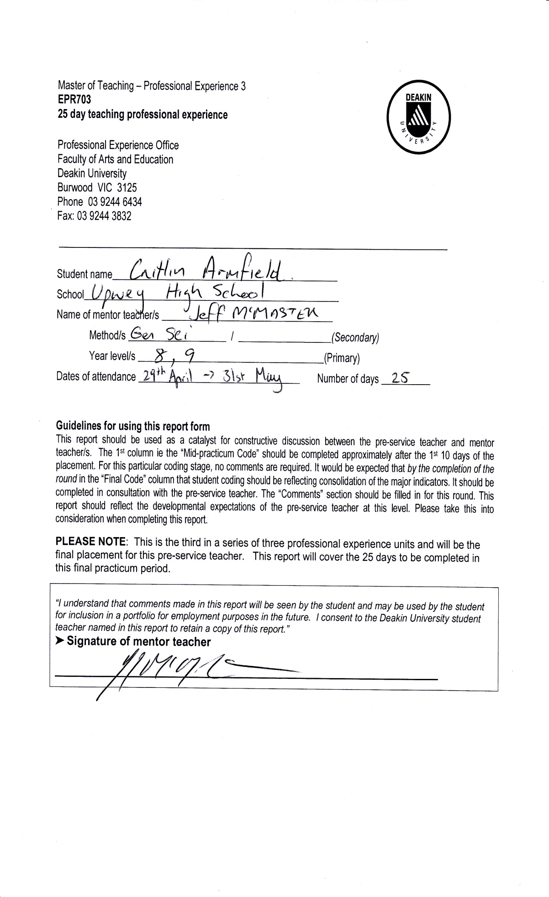
Appendix 5 – Practicum Report
